Subject Art - Year 9 Medium Term Plan/SOW |  |  |  |  |  | The Academy of St Francis of Assisi
UNIT 1 | Title : [I]DENT ity |  |  |  |  | Number of lessons in sequence | 14
Overarching Curricular Goals (Aims) (What do you intend students know about and be able to do by the end of the topic, or scheme of learning. Critical knowledge needed to inform later learning and wider contexts.) |  | By the end of this unit students will:  Understand starting points and how to use them to inspire own work (word shower)  To look at and discuss the work of Shepard Fairey using formal elements line and pattern.  To learn more about the work of Fairey, and his influences to inform own work (street art, skater scene, Russian constructivism).  learn the meaning of motifs and symbolism in street art  To make connections with the art and their own work  To create own art work on a large scale – incorporating layering of collage, typography, restricted colour and motif to create own statuesque poster. This may include political statements and bold imagery  Studnets will be able to choose their own colour pallete and be able to justify why the choice |  | Links to National Curriculum  Links to & building upon prior learning  Including KS2 if Yr7 | National curriculum KS3  SOW allows students to use a range of techniques – (collage, drawing and painting,) to record their observations in sketchbooks,  Journals - (homelearning booklets)  and other media (home learning and final piece)  This SOW offers a basis for exploring ideas around the power of image to communicate.  It promotes the use of a range of techniques and media, including drawing and printing.  It offers skills to increase their proficiency in the handling of different materials, and vocabulary to analyse and evaluate their own work, and that of others, in order to strengthen the visual impact or applications of their work.  The SOW explores the history of art, major movements (Pop Art) from the 1950’s/60’s up to the present day.  National curriculum KS2  SOW designed to engage, inspire and challenge pupils, equipping them with the knowledge and skills to experiment, invent and create their own works of art inspired by pop art movement, understanding historical and cultural developments of the time.  SOW designed to produce creative work, allowing students to explore their self, ideas and record their characteristic.  Sow promotes drawing and painting skills, while allowing evaluation.  Students will use sketch books to record their observations and use them to review and revisit ideas - value scales, AP1 feedback evidenced in final outcome – mixed media piece.  Students will develop their mastery of collage, painting, drawing techniques and printing techniques.  Students will learn about historical propaganda, and the power of it, and compare this to contemporary art which offers greater difersity.  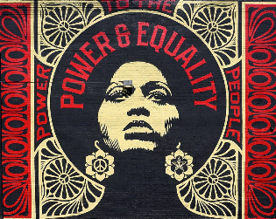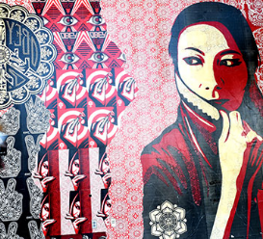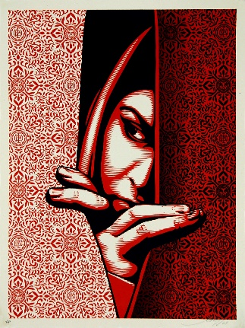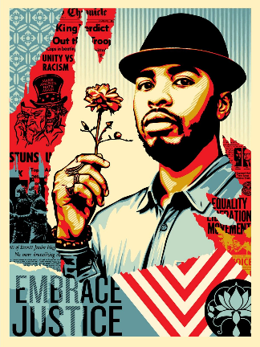  This unit year 9 explore identity and our place in the word. Students explore their culture, own beliefs, thoughts and the impact they can have in the world. This extends on from year 8 AP1 unit ME:WE, which looks at self and our immediate peers/community, and year 7 AP1 Our Selfie, which explores the theme of self.  The purpose of each AP1 unit is to act as an annual polaroid/journal, documenting the growth of each student. It is also to establish common understanding of critical fundamentals, while proudly celebrating the identity of each student, and diversity of our ASFA family.
Outcomes/  Success Criteria |  | Knowledge Learners will:  Students will learn that artists make marks, that draw attention  Art communicates, in every sense  Art has it’s own vocabulary  Artists use and abuse techniques and traditions  Artist play with ideas, materials and failures  Art engages head, heart and hand  Art is not fixed in meaning. Context is everything  Art has value in unequal measure  Art makes people powerful, for good and bad  Formal elements: Students will respond through the formal elements of colour and line  Skills:  Learners will learn:  Collage and cutting techniques – clean cut, contour cut, halo contour cut and ripped edge.  Line quality – controlled, weight of line, definition of line, outline and silhouette  Pattern – organic, geometric, organic, cultural symbolism. Contrast shapes and outlines.  Printing skills – wax resist, monoprint, emulsion print.  Drawing skills – transferring techniques  Evaluation skills using vocabulary linked to the sow.
2/3 tier vocabulary. |  | Differentiation/Scaffolding/Support. | Stretch and challenge opportunities in class, enrichment and home learning. | Opportunities for wider reading/Listening/watching.
Street art, Pop Art. Portrait. Self portrait. Clean cut, contour cut, halo contour cut and ripped edge, monochromatic, selective colour, colour palette, contrast. Constructivism. Juxtopose.  Moodboard, silhouette, layer, dry brush technique, blot, print, emulsion print. Line, pattern, motif, symbolism, organic, geometric, symmetrical, abstract, repeat. Portrait, and summary of unit words. Selective colour.  stencil, high contrast, layer, negative space, cut out, contour, dry brush technique. Vector.  Oracy:  Words will be formally introduced in lessons, repeated for familiarity and rewarded when used in context.  Also Add hyperlink to KO |  | Knowledge Support:  Knowledge organisers used every lesson  Reading support:  Key words will have visual prompts  Skills support:  Process sheets used as visual helps  Use of lead learners  Video displays  Use of visualisers  Use of demonstrations  Teacher 121 support for additional help if required | Through resources, images and wider reading recommendations.  Through time allotment on tasks within lesson and home.  Scale of tasks - All to produce A4, some MAP’s may produce A3 or A5.  Scholarship: | https://www.youtube.com/watch?v=rcSBr4ZKmrQ  Shepard Fairy – Obey this film New York skater scene, and how this influenced art  https://www.youtube.com/watch?v=DJfeAvP8xTo  Shepard Fairy – Street basics  https://www.youtube.com/watch?v=mXKS_VSwZ9k  How a Train Tunnel Became the Center of NYC’s Art Scene  https://www.youtube.com/watch?v=b7hkkmx1_lM  https://www.youtube.com/watch?v=mQURCU6jN58  Russian constructivism explained  https://www.youtube.com/watch?v=-MMwGkUioFQ  Alexander Rodchenko Russian Constructivist  Nelson Mandela, First black President of South Africa, Anti-Apartheid non-violent Activist and World Leader.  Mandela’s story  https://www.youtube.com/watch?v=PyfOrbO0xf4  Mandela’s most impactful speeches  https://www.youtube.com/watch?v=PDS_BBVfuYQ  Opportunities for wider social interaction and involvement:  • Learn about Nelson Mandela’s Gardens in prison and the types of plants he grew  • Support your clean and green campaign, like the Love Lodge Lane campaign in Liverpool  • Plant a bee garden and create an oasis for bees and other pollinators like butterflies  • Raise awareness of the importance or recycling

Unit Title  AP1 | Sequence of learning Lesson title, theme, big question. | Key concepts/outcomes/knowledge and skills.  (Could also add lesson vocab here) | Assessment/ including specific content/ knowledge/skills tested.  Green=assess/Blue=improve | HWK. Add  Hyperlink  To be in books clearly marked | Furthering Cultural Capital.  &  Opportunities for reading | Recall of prior or future topics – | Lesson resources including or hyperlink to supporting websites/resources/books/texts & individual lessons.  5xT+L essentials to be included in individual lessons,
1  Baseline | Remember  - Prior knowledge  Big question:  What do you know?  How hard will I have to challenge you? | Key word knowledge  Drawing skills  Conceptual skills  Analysis of art (writing skills) | Baseline assessment – Assessed into high, mid, low to inform seating plans and differentiation of unit resources. | Students to come to lesson with summer task completed looking at cultural identity  Homework due for next lesson. Mind map (my self, my beliefs, my culture, my thoughts) and collage images. |  | Students  demonstrate prior knowledge and understanding  To allow for greater differentiation. | Normal art room health and safety rules apply.  PPT here  Resources here
2  Introduction – Me, myself and EYE | Understand  - How to use equipment and materials correctly | Artists play with ideas, materials and failure.  Art has its own vocabulary.  Know: creative industry practice (illustration)  Understand: how a line can communicate  Create: Pattern extensions  Skill: drawing skills  Misconceptions: promoting effective composition skills, cutting skills and composition (negative space and bleeding images).  Out comes: Discussion, pattern extensions  Lesson vocabulary: Street art, collage, extension, pattern, organic, geometric, abstract, repeat, clear-cut, composition, negative space, bleeding, outline, limited colours. | 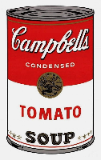v’s 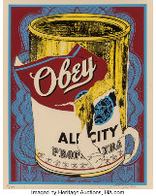  Pop art revisited and extended (year 7)  Inspiration/connection to street art explored | Mandela mandala homework based on patterns from students own culture.  67minutes to complete homework, a minute for every year of Mandela’s life.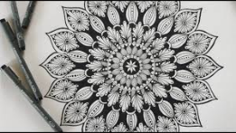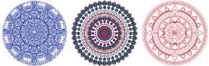https://www.youtube.com/watch?v=bYwGLNNjvE4  Extension  Research and incorporate an inspiration Mandela Quote – frame in your window, photograph it and tweet it to school art account. | Nelson Mandela, First black President of South Africa, Anti-Apartheid non-violent Activist and World Leader.  Mandela’s story  https://www.youtube.com/watch?v=PyfOrbO0xf4  Mandela’s most impactful speeches  https://www.youtube.com/watch?v=PDS_BBVfuYQ  Nelson Mandela taught us to  - Fight for equality  - Speak with conviction  - Prove them wrong  - Fight for others  - Unit people  - Be passionate about your cause  - Tell great stories  Wider impact:  • Learn about Nelson Mandela’s Gardens in prison and the types of plants he grew  • Support your clean and green campaign, like the Love Lodge Lane campaign in Liverpool  • Plant a bee garden and create an oasis for bees and other pollinators like butterflies  • Raise awareness of the importance or recycling  Home art galleries, exposure to art, promotion of art in homes. | Linked to AP1 Year 8,  ME:WE =  Students reflect on their own identity and how that relates to our school community.  Linked to AP1 Year 7, Our Selfie  [I]dentity | Normal art room health and safety rules apply.  PPT here  Resources here  Visual prompt
3  Peace piece | Apply  - Prior lessons knowledge and skills to present a moodboard  Big question:  What is art? How is it defined?  What is accessible art?  What is high art? | Students will learn that artists make marks, that draw attention  Art communicates, in every sense  Pop art has value in unequal measure  Art engages head, heart and hand.  Art has its own vocabulary.  Know: key vocabulary  Understand: The street movement  Create: Street art moodboard  Skill/ technique: collage mixed media  Outcomes: Discussion, moodboard (addressing misconceptions, focusing on cutting skills)  Lesson vocabulary: Collage, clear cut, ripped cut, contour cut, halo contour cut, accessible, culture, high art.  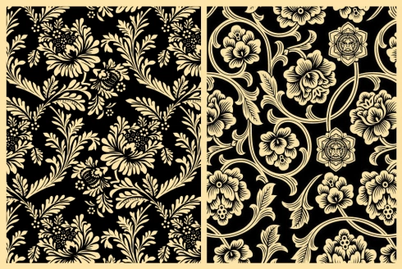 | Recall of vocabulary | Peace piece home work – apply line and pattern to create on peace piece in pen.  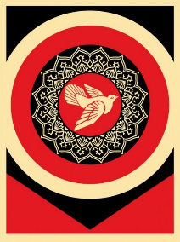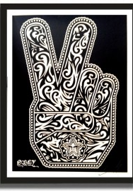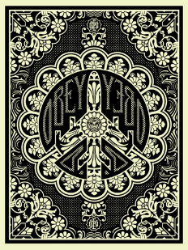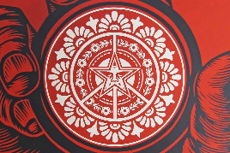 |  |  | Normal art room health and safety rules apply.  PPT here  Resources here
4  Print with intent | Apply:  - Apply prior knowledge and skills to complete a colour wheel (colour theory)  How to layer textured backgrounds | Street art has value in unequal measure  Art engages head, heart and hand.  Art has its own vocabulary.  Know: key vocabulary  Understand: how to use materials differently  Create: layered prints (oil pastel resist/ emulsion print, lino)  Skill: Printmaking skills and mixed media  Outcomes: Discussion, A5 print/s  Lesson vocabulary: monochromatic, collage, layered, print, emulsion, resist and lino. |  | Photograph of self – drawn. Second image printed for lesson.  Complete a repeat pattern based on a cultural reference. (symbolism through pattern) | Creative industry – Faile movement |  | Normal art room health and safety rules apply.  PPT here  Resources here  Mixed media backgrounds tutorial
5  Measuring up | Apply  - Apply grid method to own sourced image | Students will learn that artists make marks, that draw attention  Art communicates, in every sense  Art has it’s own vocabulary  Artists use and abuse techniques and traditions  Artist play with ideas, materials and failures  Art engages head, heart and hand  Art is not fixed in meaning. Context is everything  Know: key vocabulary  Understand: grid method  Create: line drawing from primary source  Skill: Drawing  Outcomes: Discussion, line drawing  Lesson vocabulary: line, grid, drawing. |  | Complete classwork if not complete. Take photo and turn it into high contrast image using PPT, autoart, or photoshop |  | To know how to add  Highlights to hair in self portrait – final piece. | Normal art room health and safety rules apply.  PPT here  Resources here  Visual prompt  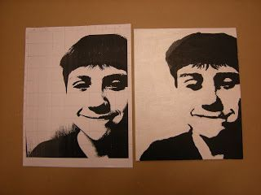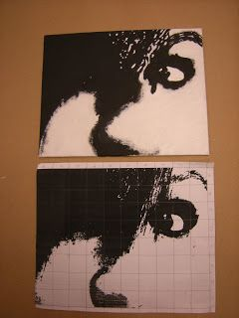
6  High  Contrast | Apply  - Contrast to line drawing | Students will learn that artists make marks, that draw attention  Art communicates, in every sense  Art has it’s own vocabulary  Artists use and abuse techniques and traditions  Artist play with ideas, materials and failures  Art engages head, heart and hand  Art is not fixed in meaning. Context is everything  Art has value in unequal measure  Art makes people powerful, for good and bad  Know: key vocabulary  Understand: where light and shade patterns on the face  Create: 3 value contrast image  Skill: observational skills and drawing techniques  Outcomes: Discussion, 3x value drawing showing contrast.  Lesson vocabulary: portrait, shade, highlight, value, contrast, mid tone, shadow, silhouette, outline, pressure. |  | 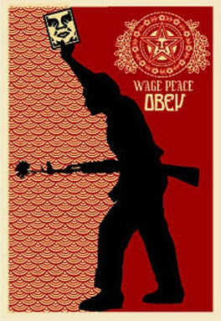  Lesson extension.  Expanding contrast into silhouette.  Inspired by the work of Fairy, students create a silhouette collage or photo. | Exposure to online digital art galleries  Liverpool Open eye. |  | Normal art room health and safety rules apply.  PPT here  Resources here  Visual prompt  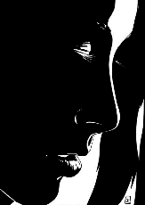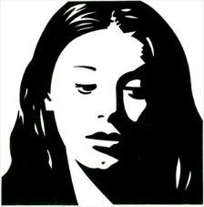  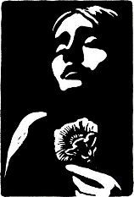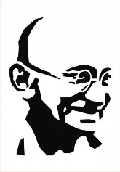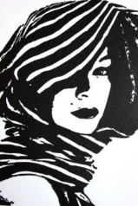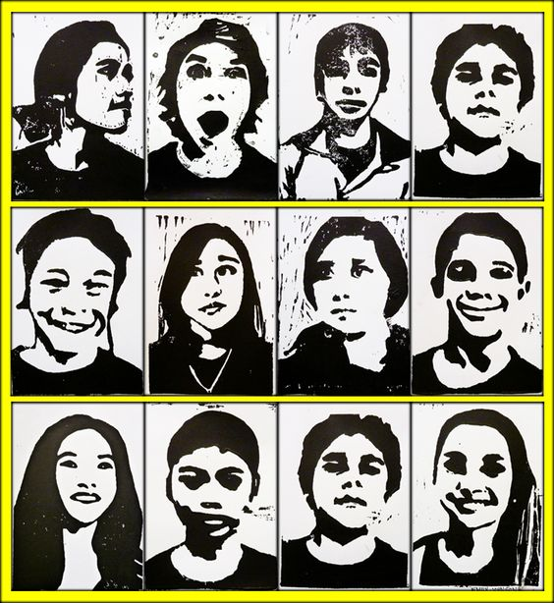
7 All about assessment | Apply  - Combined painting skills to lines arranged abstract  Analyse  - The success of colour mixing and painting | Students will learn that artists make marks, that draw attention  Art communicates, in every sense  Art has it’s own vocabulary  Art engages head, heart and hand  Artists use and abuse techniques and traditions  Artist play with ideas, materials and failures  Art is not fixed in meaning. Context is everything  Art has value in unequal measure  Art makes people powerful, for good and bad  Know: key vocabulary  Understand: Drawing and printing skills  Create: An first draft of final (practice for final piece)  Outcomes: Discussion, first draft of final  Lesson vocabulary: all to date | Deep marking assessed piece.  Assessed on mixed media skills, ability to combine and control printing techniques.  Feedback given, action to be demonstrated in final outcome, week 9 and 10 | Students research the work of Fairy and create an artist information page demonstrating the skills they have learned. |  |  | Normal art room health and safety rules apply.  PPT here  Resources here  Visual prompt
8  Stencil | Apply cutting skills to line drawings to create stencils | Students will learn that artists make marks, that draw attention  Art communicates, in every sense  Art has it’s own vocabulary  Art engages head, heart and hand  Artists use and abuse techniques and traditions  Artist play with ideas, materials and failures  Art is not fixed in meaning. Context is everything  Art has value in unequal measure  Art makes people powerful, for good and bad  Know: key vocabulary  Understand: Drawing, cutting and printing skills  Create: stencil samples  Skill: Dry brush technique, layering and contrast  Outcomes: Discussion, stencil samples  Lesson vocabulary: stencil, high contrast, layer, dry brush technique. Vector. |  | Show me boxed, linked to assessment feedback to demonstrate action on feedback given.  Research relevant vectors to make stencil. |  |  | Enhanced art room health and safety rules apply due to use of craft knife. Please see additional health and safety instructions attached to slide.  PPT here  Resources here
9  Who you talking to, Punk? | Apply  - Text to first draft  Analyse  - The influence of words in art to convey a message | Students will learn that artists make marks, that draw attention  Art has it’s own vocabulary  Art engages head, heart and hand  Artist play with ideas, materials and failures  Art has value in unequal measure  Art makes people powerful, for good and bad  Know: key vocabulary  Understand: the power of slogans  Create: slogan/text/message for own work  Skill: collage and thinking skills.  Outcomes: Discussion, 3 tonal values showing African American, Asian and Caucasian mixing skills.  Lesson vocabulary: persuasion, message, meaning power, typography, low art, punk/pop art, vector, historic, contemporary. |  | Propaganda research page, and create a poster based on an message of importance. | Then. historic  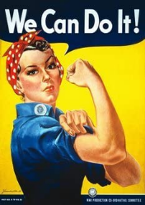  Now. Contemporary revival  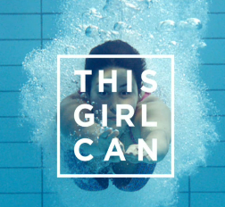  Then. historic  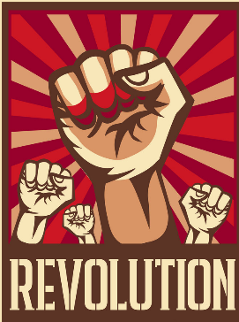  Now. Contemporary revival |  | Normal art room health and safety rules apply.  PPT here  Resources here  Visual prompt  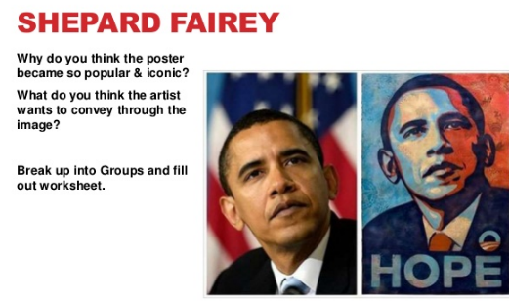  Compare and contrast meaning of these?  Pop art/punk reference  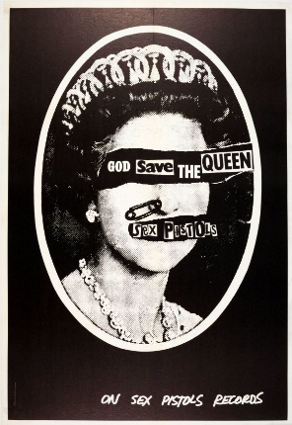
10 textured background of final outcome | Create and evaluate  Progression of final outcome  Artist work and tracing technique | Students will learn that artists make marks, that draw attention  Art communicates, in every sense  Art has it’s own vocabulary  Art engages head, heart and hand  Artists use and abuse techniques and traditions  Art has value in unequal measure  Art makes people powerful, for good and bad  Know: key vocabulary and how to use equipment safely  Understand: how to layer techniques in the style of an artist  Create: a textured background with extended pattern  Skill: drawing, printing skills and transfer techniques.  Skill: Artist analysis and mixed media skills, using line  Outcomes: Discussion, beginning of final piece  Lesson vocabulary: All to date | Whole unit vocabulary check.  Spelling test |  |  |  | Normal art room health and safety rules apply.  PPT here  Resources here  Visual prompt
11  Line drawing of final outcome, printing, and stencilling | Create  Develop final outcome | Students will learn that artists make marks, that draw attention  Art communicates, in every sense  Art engages head, heart and hand  Art has it’s own vocabulary  Artists use and abuse techniques and traditions  Art has value in unequal measure  Know: key vocabulary and how to use equipment safely  Understand: develop a final piece to demonstrate learned skills/techniques  Create: an outline of self, adding high contrast and/or stencilling  Skill: Artist analysis, drawing skills, refinement skills  Outcomes: Discussion, evaluating final piece.  Lesson vocabulary: Self-portrait, and summary of unit words. |  | Homework to add here |  |  | Normal art room health and safety rules apply.  PPT here  Resources here  Visual prompt
12  Final piece complete | Create and evaluate  - Final details - text, cultural patterns. | Students will learn that artists make marks, that draw attention  Art communicates, in every sense  Art engages head, heart and hand  Art has it’s own vocabulary  Artists use and abuse techniques and traditions  Art has value in unequal measure  Know: key vocabulary and how to use equipment safely  Understand: how to complete work in the style of Fairy  Create: final piece using primary sources and iconology relevant to students  Skill: Artist analysis, painting skills and evaluation  Outcomes: Discussion, completed piece, evaluation of work.  Lesson vocabulary: all vocabulary to date | Final piece deep marked and reported on.  Drawing:  Assessed on ability to apply either organic, geometric or cultural pattern, quality of line to depict likeness of self, quality of text/message.  Printing:  Assessed on printing skills, ability to control the paint, clarity, ability to mix and layer techniques and overall presentation.  Evaluation:  Ability to act on feedback at week 7. Assessed on spelling and ability to identify strengths and weaknesses.  Assessed on overall homework response and ability to meet deadline. |  |  | Cultural element linked to cultural projects = Brazil in Year 8.  Cultural element linked to year 7 Our selfie, ABCDEFG | Normal art room health and safety rules apply.  PPT here  Resources here  Visual prompt  Skilled outcome:  Collage background  At least one printing technique  High contrast image using secondary resources  Clear drawing skills  Clear use of control drawing lines  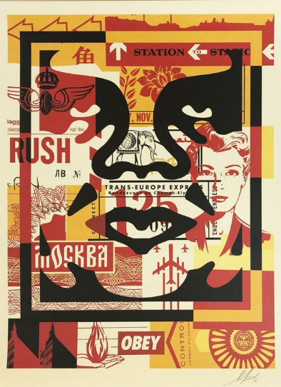  EBI: cultural pattern was used, and message was considered  Confident outcome:  Restricted colour palette  Range of collage, printing and drawing techniques  Cultural patterns  Skilled facial study  Contrast extended into colour  Clear issue based – messages clear (ant pollution , and destruction of peace for oil)  