n

Subject Art - Year 7 Medium Term Plan/SOW |  |  |  |  |  | The Academy of St Francis of Assisi
UNIT 1 | Title : Pop Art Portraits |  |  |  |  | Number of lessons in sequence | 14
Overarching Curricular Goals (Aims) (What do you intend students know about and be able to do by the end of the topic, or scheme of learning. Critical knowledge needed to inform later learning and wider contexts.) |  | By the end of this unit students will:  Students will study how Pop Art has influenced colour and line. They will gain a greater appreciation for the value of the history of art, how pop art communicates and engages the head, heart and hand. |  | Links to National Curriculum  Links to & building upon prior learning  Including KS2 if Yr7 | National curriculum KS3  SOW allows students to use a range of techniques – (collage, drawing and painting,) to record their observations in sketchbooks,  Journals - (comic book diary)  and other media (artist business cards and final piece)  This SOW offers a basis for exploring ideas around the power of image to communicate.  It promotes the use of a range of techniques and media, including painting.  It offers skills to increase their proficiency in the handling of different materials, and vocabulary to analyse and evaluate their own work, and that of others, in order to strengthen the visual impact or applications of their work.  The SOW explores the history of art, major movements (Pop Art) from the 1950’s/60’s up to the present day.  National curriculum KS2  SOW designed to engage, inspire and challenge pupils, equipping them with the knowledge and skills to experiment, invent and create their own works of art inspired by pop art movement, understanding historical and cultural developments of the time.  SOW designed to produce creative work, allowing students to explore their self, ideas and record their characteristic.  Sow promotes drawing and painting skills, while allowing evaluation.  Students will use sketch books to record their observations and use them to review and revisit ideas - value scales, AP1 feedback evidenced in final outcome.  Students will develop their mastery of collage, painting and drawing techniques.  Students will learn about great artists, historical (Warhol) and contemporary (Opi) who offers greater diversity.  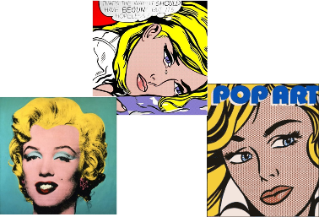 v’s  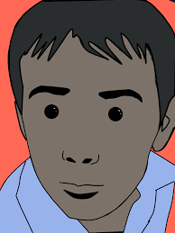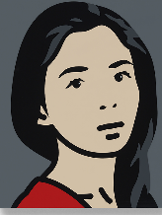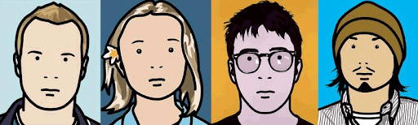  This unit is an extension of a popular primary topic, allowing familiarity and way to establish common understanding of critical fundamentals, while proudly celebrating the identity of each student, and diversity of our ASFA family.
Outcomes/  Success Criteria |  | Knowledge Learners will:  Students will learn that artists make marks, that draw attention  Art communicates, in every sense  Art has it’s own vocabulary  Artists use and abuse techniques and traditions  Artist play with ideas, materials and failures  Art engages head, heart and hand  Art is not fixed in meaning. Context is everything  Art has value in unequal measure  Art makes people powerful, for good and bad  Formal elements: Students will respond through the formal elements of colour and line  Skills:  Learners will learn:  Collage and cutting techniques – clean cut, contour cut, halo contour cut and ripped edge.  Colour theory – Hue, value, primary, secondary, tertiary, monochromatic, complimentary, triadic, harmonious, analogous, intensity, value and ratio.  Painting skills – how to hold a brush, how to clean and maintain brush and watercolours, and how to colour mix tints, shades and skin tones using a limited colour palette.  Drawing skills – transferring techniques  Evaluation skills using vocabulary linked to the sow.
2/3 tier vocabulary. |  | Differentiation/Scaffolding/Support. | Stretch and challenge opportunities in class, enrichment and home learning. | Opportunities for wider reading/Listening/watching.
Pop Art. Portrait. Self portrait. Clean cut, contour cut, halo contour cut and ripped edge, composition, negative space, bleeding, hue, value, primary, secondary, tertiary, monochromatic, complimentary, triadic, harmonious, analogous, intensity, value, ratio, transfer, tints, shades, skin tones, colour palette.  Pop art movement, abstract, portrait, portraiture, selfie, moodboard, doppelgänger.  Ratio, range, African American, Asian, Caucasian.  Line, transfer, pressure, reverse, masking tape.  Self-portrait, and summary of unit words. Selective colour.  Oracy:  Words will be formally introduced in lessons, repeated for familiarity and rewarded when used in context.  Also Add hyperlink to KO |  | Knowledge Support:  Knowledge organisers used every lesson  Reading support:  Key words will have visual prompts  Skills support:  Process sheets used a visual helps  Use of lead learners  Video displays  Use of visualisers  Use of demonstrations  Teacher 121 support for additional help if required | Through resources  Through time allotment  Scale of tasks  Home learning outcomes  Scholarship: | Flake - Mathew Dooley  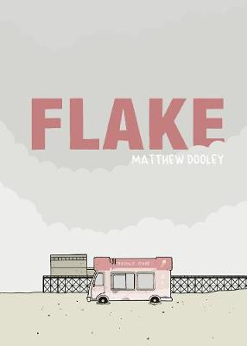  https://www.beyondthejoke.co.uk/content/9002/matthew-dooley-prize

Unit Title  AP1 | Sequence of learning Lesson title, theme, big question. | Key concepts/outcomes/knowledge and skills.  (Could also add lesson vocab here) | Assessment/ including specific content/ knowledge/skills tested.  Green=assess/Blue=improve | HWK. Add  Hyperlink  To be in books clearly marked | Furthering Cultural Capital.  &  Opportunities for reading | Recall of prior or future topics – | Lesson resources including or hyperlink to supporting websites/resources/books/texts & individual lessons.  5xT+L essentials to be included in individual lessons,
1  Baseline | Remember  - Prior knowledge  Big question:  What do you know?  How hard will I have to challenge you? | Key word knowledge  Drawing skills  Painting skills  Analysis of art (writing skills) | Baseline assessment – Assessed into high, mid, low to inform seating plans and differentiation of unit resources. | Students to come to lesson with summer task completed – Selfie multiple choice task.  Homework due for next lesson, extension of baseline. Creative colour wheel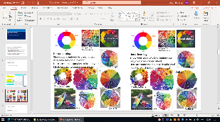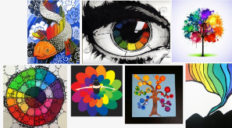 |  | Students  demonstrate prior knowledge and understanding  To allow for greater differentiation. | Normal art room health and safety rules apply.  PPT here  Resources here  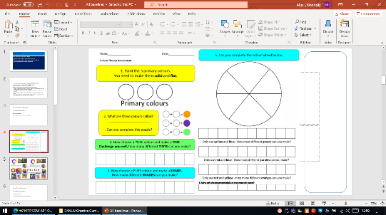
2  Introduction – Self  Born to be | Understand  - How to use equipment and materials correctly  Big question:  Who, be, she?  Who, be, me?  Who, be, we?  What makes effective composition? | Artists play with ideas, materials and failure.  Art has its own vocabulary.  Know: creative industry practice  Understand:  Create: Miniature selfie Artist business card  Skill: cutting skills, painting skills and collage skills.  Misconceptions: promoting effective composition skills, cutting skills and composition (negative space and bleeding images).  Out comes: Discussion, selfie business card.  Lesson vocabulary: Collage, clear-cut, composition, negative space, bleeding, outline, limited colours. |  | Selfie task  and research pop art images to bring to lesson. | Modelling creative industry practice - artist business cards | Linked to AP1 Year 8,  ME:WE =  Students reflect on their own identity and how that relates to our school community.  Linked to AP1 Year 9,  [I]dentity =  Students research their cultural identity, celebrate the social impact ior express a relevant message to inform others. | Normal art room health and safety rules apply.  PPT here  Resources here  Visual prompt
3  Introducation to the movement – What a load of banana’s! | Apply  - Prior lessons knowledge and skills to present a moodboard  Big question:  What is popular culture?  Why is it significant?  What is low art?  What is high art?  What makes Pop Art Banana’s?  Is media harmless?  Can a can of soup ever be more than a can of soup? | Students will learn that artists make marks, that draw attention  Art communicates, in every sense  Pop art has value in unequal measure  Art engages head, heart and hand.  Art has its own vocabulary.  Know: key vocabulary  Understand: The movement  Create: pop art moodboard  Skill/ technique: collage mixed media  Outcomes: Discussion, moodboard (addressing misconceptions, focusing on cutting skills)  Lesson vocabulary: Collage, clear cut, ripped cut, contour cut, halo contour cut. | Recall of vocabulary | A6 Pop art typography/explosion and spellings.  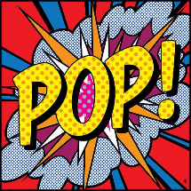  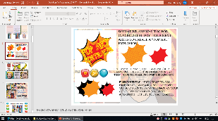 | 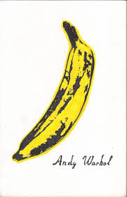  The banana became an iconic symbol for wealth, with the rise of importing goods we now take for granted. Fruit was considered a luxury. Could what we consider as a luxury today, be taken for granted in the future?  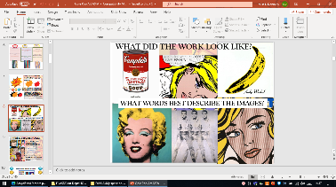  Narrow media representation (western standards) of female beauty and erratic emotional states.  What message do they convey? How powerful are these images on society?  Are there any modern day examples of this?  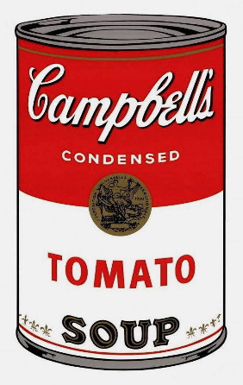  What can we learn from this image?  The soup can became one of PopArt's most iconic symbols.  It represents the very first instant/convenient foods of the time. This was a landmark product as it freed women from traditional domestic duties, allowing them time to enter the workforce, which in turn, allowed them to be financially independent.  What, today, could be said to have similar significance or meaning? | Pop art projects in primary. | Normal art room health and safety rules apply.  PPT here  Resources here  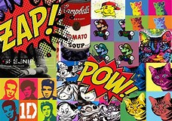
4  Magic mix | Apply:  - Apply prior knowledge and skills to complete a colour wheel (colour theory)  What colour should I use?  Why, how, what, when?  What happens when...? | Pop art has value in unequal measure  Art engages head, heart and hand.  Art has its own vocabulary.  Know: key vocabulary  Understand: Colour theory  Create: a painted colour wheel  Skill:  Outcomes: Discussion, colour wheel  Lesson vocabulary: formal element, colour, hue, value, intensity, primary, secondary, tertiary, monochromatic, complimentary, harmonious, analogous. Doppleganger. |  | Doppleganger artist pape learning spellings of key words. Spelling test as settler.  Students take a selfie, upload it to website which locates fine art that resembles them.  Students present an artist page on the artist you resemble.  Include your selfie  Include the image of the artist  Include 5 facts about the artist  Analyse the art work using formal element colour  Share your opinion of the artists work  Find two additional ways in which you are similar to the artist | Low art v’s high art and accessibility.  Introduction to world museums virtual experience. Use Your Selfie (pop-art) to Find Your Fine Art (high art) Doppelgänger. |  | Normal art room health and safety rules apply.  PPT here  Resources here  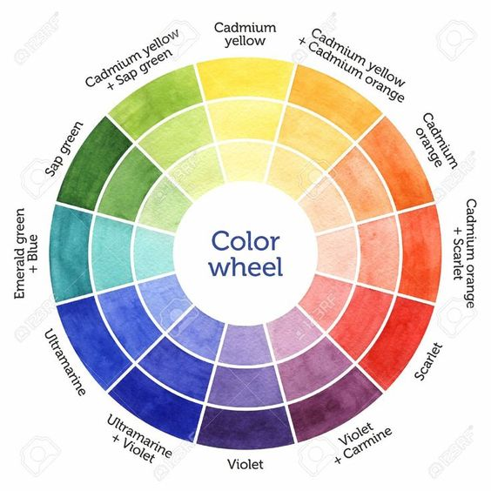
5  Tint-tastic | Apply  - mixing skills to value scales  Why?  To maximise painting ability | Students will learn that artists make marks, that draw attention  Art communicates, in every sense  Art has it’s own vocabulary  Artists use and abuse techniques and traditions  Artist play with ideas, materials and failures  Art engages head, heart and hand  Art is not fixed in meaning. Context is everything  Know: key vocabulary  Understand: mixing ratio and painting skills  Create: 3xvalue scales showing tints.  Skill: Painting  Outcomes: Discussion, 3x value scales showing increasing refinement.  Lesson vocabulary: Tint, ratio, colour mixing and value scales. |  | Self-portrait drawing using line  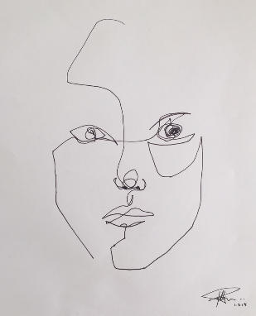  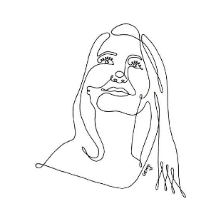  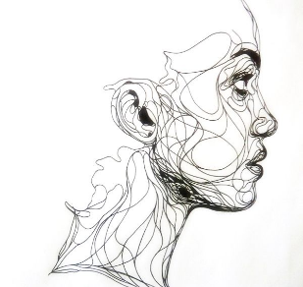 |  | To know how to add  Highlights to hair in self portrait – final piece. | Normal art room health and safety rules apply.  PPT here  Resources here  Visual prompt  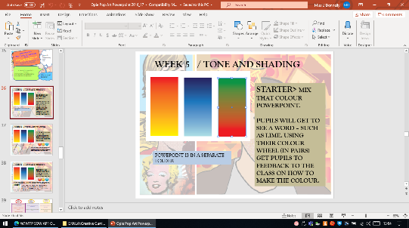
6  Shade fade | Apply  - Mixing skills to creates shade value scales  Analysis  - the success of mixing and painting | Students will learn that artists make marks, that draw attention  Art communicates, in every sense  Art has it’s own vocabulary  Artists use and abuse techniques and traditions  Artist play with ideas, materials and failures  Art engages head, heart and hand  Art is not fixed in meaning. Context is everything  Art has value in unequal measure  Art makes people powerful, for good and bad  Know: key vocabulary  Understand: Mixing ratios and painting skills  Create: 3xvalue scales  Skill: Painting techniques  Outcomes: Discussion, 3x value scales showing increasing refinement showing shade.  Lesson vocabulary: formal element, colour, hue, value, intensity, primary, secondary, tertiary, monochromatic, complimentary, harmonious, analogous. Self portrait. |  | Research personal values.  Contour typography draft for final. | Assessed. Students comment/reflection, and refinements to be evident in final piece. | Key skills and vocab support all SOW  Use of line has links to “Birds with issues”, which recaps and extends line. | Normal art room health and safety rules apply.  PPT here  Resources here  Visual prompt  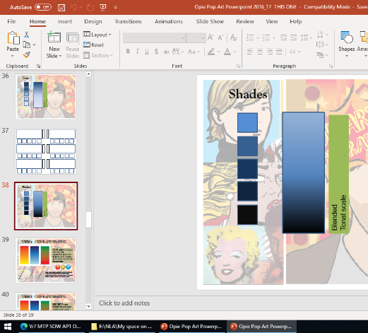
7 All about Abstract | Apply  - Combined painting skills to lines arranged abstract  Analyse  - The success of colour mixing and painting | Students will learn that artists make marks, that draw attention  Art communicates, in every sense  Art has it’s own vocabulary  Art engages head, heart and hand  Artists use and abuse techniques and traditions  Artist play with ideas, materials and failures  Art is not fixed in meaning. Context is everything  Art has value in unequal measure  Art makes people powerful, for good and bad  Know: key vocabulary  Understand: Drawing and Painting skills  Create: An abstract background (practice for final piece)  Outcomes: Discussion, an abstract background.  Lesson vocabulary: abstract, tine, shade | Deep marking assessed piece.  Assessed on painting skills, ability to control the paint, vibrancy, ability to mix the paint :tints and shades.  Feedback given, action to be demonstrated in final outcome, week 9 and 10 | Students research the work of Julian Opie and create an artist information page demonstrating the compositional skills they have learned.  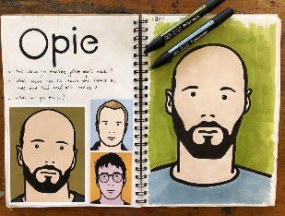 |  | Extension from line homework, previous week  Links to Year 8 and 9 sow reflecting on self and characteristics of value and merit. | Normal art room health and safety rules apply.  PPT here  Resources here  Visual prompt  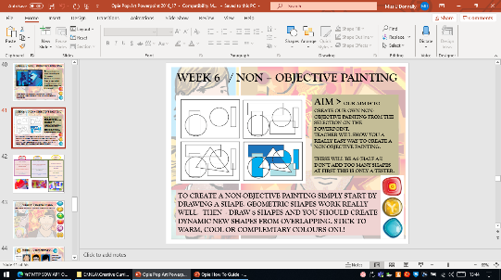
8  Skin Skill | Apply  - Mixing skills to create a range of skin tones.  Analyse  - The success of mixing skills and painting | Students will learn that artists make marks, that draw attention  Art has it’s own vocabulary  Art engages head, heart and hand  Artist play with ideas, materials and failures  Art has value in unequal measure  Art makes people powerful, for good and bad  Know: key vocabulary  Understand: Mixing ratios and painting skills  Create: 3 value scales showing a range of skin tones  Skill: Artist analysis and drawing skills using line  Outcomes: Discussion, 3 tonal values showing African American, Asian and Caucasian mixing skills.  Lesson vocabulary: Ratio, range, African American, Asian, Caucasian. |  | Comic book diary |  |  | Normal art room health and safety rules apply.  PPT here  Resources here  Visual prompt  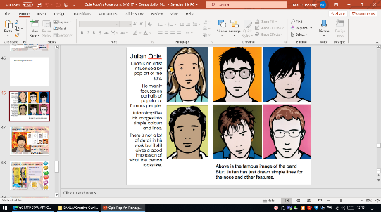
9 Outline of final piece | Create and evaluate  Line drawing from primary image  Artist work and tracing technique | Students will learn that artists make marks, that draw attention  Art communicates, in every sense  Art has it’s own vocabulary  Art engages head, heart and hand  Artists use and abuse techniques and traditions  Art has value in unequal measure  Art makes people powerful, for good and bad  Know: key vocabulary and how to use equipment safely  Understand: how to draw in the style of an artist  Create: an outline of their self portrait using primary source in the style  Skill: drawing skills and transfer techniques.  Skill: Artist analysis and drawing skills using line  Outcomes: Discussion, outline of themselves.  Lesson vocabulary: Line, transfer, pressure, reverse, masking tape. | Whole unit vocabulary check.  Spelling test | Comic book storyboard | Careers in art – illustration  Flake – Matthew Dooley  https://www.beyondthejoke.co.uk/content/9002/matthew-dooley-prize  Flake wins the 2020 Bollinger Everyman Wodehouse Prize for Comic Fiction with graphic novel Flake – where two siblings quarrel over ice cream. |  | Normal art room health and safety rules apply.  PPT here  Resources here  Visual prompt  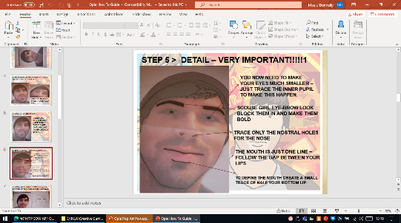
10  Painting of final piece. | Create  - Line to primary image  Analysis  - Tracing effect | Students will learn that artists make marks, that draw attention  Art communicates, in every sense  Art engages head, heart and hand  Art has it’s own vocabulary  Artists use and abuse techniques and traditions  Art has value in unequal measure  Know: key vocabulary and how to use equipment safely  Understand: how to paint their work in the style of Opie  Create: an outline of their self-portrait using primary source.  Skill: Artist analysis, painting skills, refinement skills  Outcomes: Discussion, completed piece, evaluation of work.  Lesson vocabulary: Self-portrait, and summary of unit words. |  | “ABCDEFG” - iconic  Independent homework response.  Kourtney Kardashian meme.  Pop culture.  Perceived, low art, trash TV.  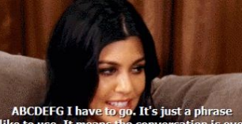  Students respond by choosing a chakra and colour to create their artwork. | Buddhism practice and beliefs.  Wellbeing  Actual reference:  A,B,C,D,E,F,G =  The musical notes assigned to chakras, each one representing a meaning, and linked to a colour. Meaning raised by cultural significance.  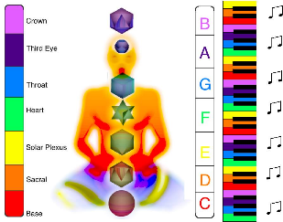  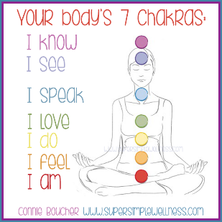 | Links to cultural element, Brazilian art, Year 8.  Links to media message, codes and hidden symbols s in Year 9, [I]dentity | Normal art room health and safety rules apply.  PPT here  Resources here  Visual prompt  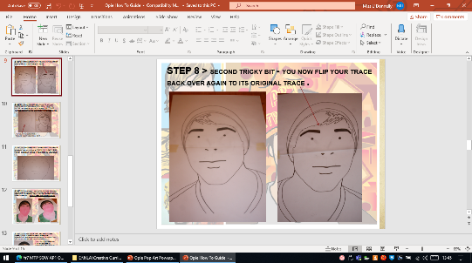
11  Final piece complete | Create and evaluate  - Line to primary image  Analysis  - Tracing effect | Students will learn that artists make marks, that draw attention  Art communicates, in every sense  Art engages head, heart and hand  Art has it’s own vocabulary  Artists use and abuse techniques and traditions  Art has value in unequal measure  Know: key vocabulary and how to use equipment safely  Understand: how to paint their work in the style of Opie  Create: an outline of their self-portrait using primary source.  Skill: Artist analysis, painting skills and evaluation  Outcomes: Discussion, completed piece, evaluation of work.  Lesson vocabulary: Self-portrait, and summary of unit words. Selective colour. | Final piece deep marked and reported on.  Drawing:  Assessed on likeness to self, ability to apply Opie characteristic to self, quality of line, quality of contour typography and legibility.  Painting:  Assessed on painting skills, ability to control the paint, vibrancy, ability to mix the paint :tints and shades and overall presentation.  Evaluation:  Ability to act on feedback at week 7. Assessed on spelling and ability to identify strengths and weaknesses.  Assessed on overall homework response and ability to meet deadline. |  |  | Cultural element linked to cultural projects = Brazil in Year 8. | Normal art room health and safety rules apply.  PPT here  Resources here  Visual prompt  