Soya and Tofu

Soya beans can be used to make spya milk, soya flour, soy sauce

Soya products such as tofu and soya mince are alternatives to meat

Soya and tofu can have a bland flavour, so they need to be cooked with ingredients that have a stronger flavour, like chilli and garlic

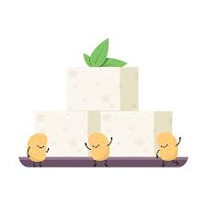

Yoghurt

Yoghurt is made using harmless bacteria

Types of yoghurt include set, stirred and live

Good source of calcium and HBV protein

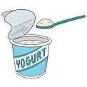

Cheese

Cheese is a solid or semi solid form of milk

Source of HBV protein and a good source of calcium

Cheese has many functions including proving flavour, colour, texture and nutritional value to many dishes

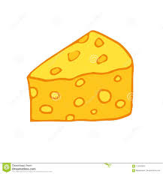

Fish

Three main types are oily, white and shellfish

Can be cooked quickly

Source of HBV protein, some fat and vitamins A &D

Fish spoils quickly and must be eaten as quickly as possible after buying



Poultry

Includes chicken, turkey, duck, guinea fowl, pigeon

Made up of protein, water and fat

High risk food that needs to be cooked and stored correctly

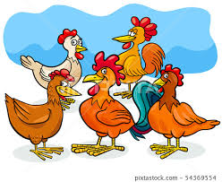

Meat

Meat is made up of protein, water and fat

Fat in meat is either visible or invisible

Meat is a source of HBV protein, iron, fat and some vitamins

Meat is a high-risk food and must be stored and cooked correctly to avoid food poisoning

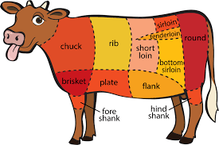

Flour

Wheat flour is one of the main flours produced

Strong flour is high in gluten, best for bread making

Plain flour is best for pastry, biscuits and sauces

White flour is fortified with vitamins and minerals

Flour should be stored in an airtight container in a cool, dry cupboard

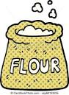

Beans

Beans are also known as legumes and pulses

Beans include chickpeas, kidney beans, black beans, runner beans

Beans can be bought dried, canned fresh and frozen

Beans are an excellent source of fibre and protein



Eggs

Eggs come in the following sizes – small, medium, large and extra large

Egg types depends on the type of conditions the hens have been kept in

The biggest part of the egg is the white

Eggs provide a range of nutrients including protein, fat soluble vitamins and iron

Eggs should be stored at an ambient temperature

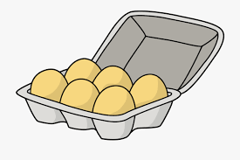

Potatoes

Potato varieties include King Edward, Jersey Royal and Maris Piper

Potatoes are a good source of vitamin C

Should be stored in a dry, cool, dark place

The part of the potato plant we eat is called the tuber

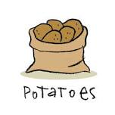

Rice

Rice gives a feeling of fullness

Rice can be steamed, stir fried, baked or boiled

Rice can be long or short grain

Cooked rice is a high risk food

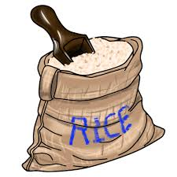

Milk

Milk is heat treated to make it safe to use

Pasteurisation and UHT are two methods used to heat treat milk

Whole, semi skimmed, and skimmed milk are sold in shops

Milk is a ‘complete’ food

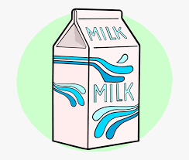

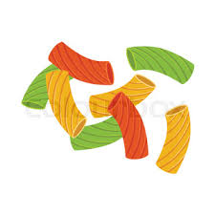

Nuts and Seeds

Nuts can cause allergic reactions

Nuts can be bought shelled, ground, chopped

Nuts are good source of fibre and protein

Seeds can be included in many dishes to increase their nutritional value

Many seeds are used to make oils

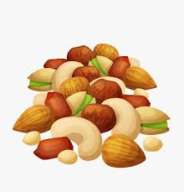

Pasta

Pasta is made from durum wheat and water

Many shapes, styles and sizes are sold

Pasta can be made into different colours by adding extra ingredients

Pasta can be bought fresh or dried

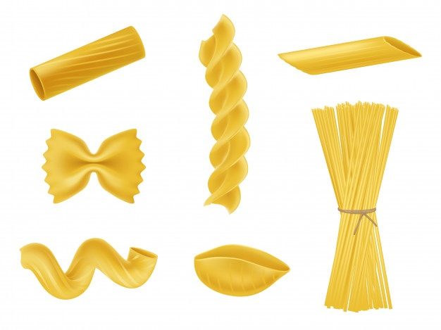

**Keywords**

**Nutritional Value: How nutritious a certain food is (the amount of carbohydrate, protein, fat, vitamins and minerals it gives the body)**

**Maillard Reaction: Chemical reaction between proteins and carbohydrates, which changes the flavour of the food**

**Denature: The unravelling of the bonds that hold amino acids together in proteins, and the creation of a different structure of amino acids**

**Coagulation: This is when protein denatures and forms a solid structure**

**Year 10 GCSE Food Preparation, Cooking and Nutrition Knowledge Organiser AP1**

Carbohydrates

* Carbohydrates provide energy when digested
* Monosaccharides and disaccharides are simple carbohydrates and can also be called simple sugars
* Sugar has no nutrients and just provides energy
* Polysaccharides are complex carbohydrates
* Starch takes longer to break down so fills us up for longer
* NSP is not digested by the body but helps with digestion and prevents constipation
* Eating too many carbohydrates will mean we put on weight, as excess is stored as fat
* It is recommended that one third of your daily food intake should be carbohydrates

Fats and Oils

* Fats are used as an energy source, to protect our vital organs, to keep us warm and provide vitamins A, D, E &K
* Fat gives food texture and flavour and helps fill us up
* Saturated fats have two hydrogen atoms per carbon atom and are mainly animal fats. They can increase cholesterol levels
* Monounsaturated fats have one hydrogen atom to a pair of carbon atoms. They can help lower cholesterol levels
* Polyunsaturated fats have more than one hydrogen space and ill not go solid in the fridge
* Hydrogenation adds hydrogen to oils to turn them into solid fats. These can be dangerous to our health
* Essential fatty acids are small units of fat needed to keep our bodies functioning properly

Protein

* Protein is a macronutrient
* Protein is needed for growth, repair and maintenance of the body, to make enzymes and hormones and as a secondary energy source
* There are nine essential amino acids. Food containing these are known as HBV proteins
* HBV proteins are found in meat, fish, eggs milk, cheese and soya
* LBV sources of protein are cereals, peas, beans, lentils, nuts and seeds
* If we do not have enough protein, we will become thin and weak
* Babies, children, teenagers, pregnant women and lactating mothers need more protein than adults.

Vitamins and Minerals

* Vitamins and minerals are micronutrients that are needed for the body to function correctly, as they help to regulate chemical reactions in the body, promote health and prevent diseases. They are needed in tiny quantities.
* Vitamins are known by letters, but all have chemical names
* A balanced diet should provide all the vitamins needed for a healthy body
* Vitamins are either fat soluble or water soluble
* Lack of any of the vitamins in the diet will mean your body cannot function properly
* Minerals are micronutrients needed in tiny quantities
* Calcium and iron are the two main minerals that we need