|  |
| --- |
| **Key People**: Class charts points if you can complete extra research on these people |
| Cheddar Man – A man who lived c.8000 BC; his skeleton is one of the oldest we have found in Britain. |
| Boudicca. - Celtic woman who led a rebellion against the Romans in 60AD and tried to resist their power |
| Ivory Bangle Lady - The remains of a Roman women found in York. She was a high-status adult woman of North African descent who died in the 4th century AD. |
| Hadrian the African – A Libyan refugee who spread Christianity and education in England in the 7th century |
| Bede 7th century Anglo-Saxon Monk and historian |
|  |
| Hilda of Whitby A powerful religious woman who was the Abbess (head nun) of Whitby Abbey |
| Alfred the Great – King of England in the 9th century. Famous for defending his kingdom against Viking invaders. |
| Aethelflaed - a rich and powerful Anglo-Saxon woman in the 10th century |
| Athelstan - the first true king of all England. Defeated the Vikings in the 10th century. |

**Knowledge Organiser –**

**Who were The First English People?**

|  |  |
| --- | --- |
| 1. Doggerland | The area of land that used to connect Britain to northern Europe |
| 2. settlers | Someone who moves to a new area |
| 3. innovation | Invention / something new |
| 4. plough | Tool used for farming |
| 5. archaeologist | A person who studies history by digging up ancient sites |
| 6. rebellion/revolt | Resistance or an attack on the government or people in power |
| 7. invade /conquer | To take over another country by force |
| 8. Beowulf | An Anglo-Saxon poem |
| 9. ransack/plunder | To go through a place, stealing things |
| 10. warrior | A brave fighter |
| 11. empire | A group of countries ruled by one country |
| 12. trade | The buying and selling of goods |
| 13. Danelaw | The areas of Anglo-Saxon England that was ruled by Vikings |
| 14. hunter-gatherers | People who live by moving from place to place, hunting for food. |
| 15. nomadic | To move around from place to place and not settle. |
| 16. agriculture | farming |
| 17. flourish | To do well; to grow healthily. |
| 18. migrate | To move to another area |
| 19. monastery/ Abbey | A religious building |
| 20. monks/nuns | Men and women who live in monasteries and give their life to God. |

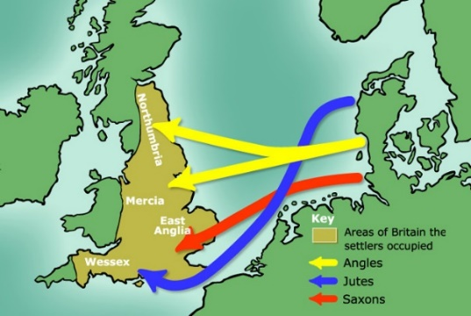

**Anglo-Saxons**

**Celts**

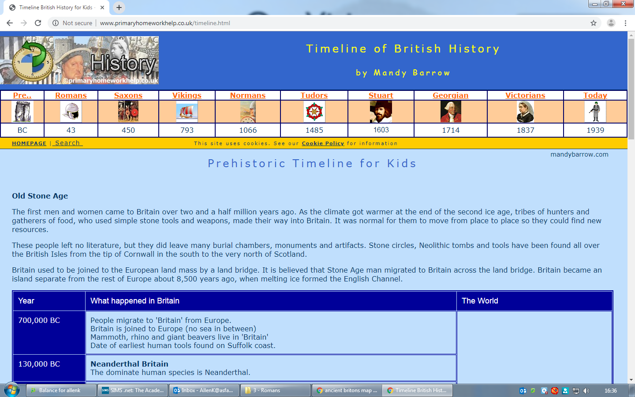

**Romans**

Doggerland used to be here

**Vikings**

AD 793

AD 450

AD 43

300 BCE

This period is known as the early Saxon and medieval period

The Roman Era

The Celts lived in the Iron Age

**Significant** = Important

|  |  |
| --- | --- |
| **What did each group of settlers bring to the British Isles?** | |
| **Celts** | Iron; iron plough; defensive hill forts; shields and highly skilled weapons. Irish language and culture. |
| **Romans** | Infrastructure; roads; towns; language; coins; vegetables; aqueducts (to get water to villages); drains |
| **Anglo-Saxons** | Pagan gods; language; Poetry (Beowulf); Greek language and poetry; structure of the Christian church; introduced English laws; united all England |
| **Vikings** | Language (old Norse words became English); names of towns e.g. Whitby; longboats and ships; hair combs; Danelaw |