**J’aime & Infinitive**

You can use infinitives after

J’aime – I like

Je n’aime pas – I do not like

J’adore – I love

Je déteste – I hate

To say what you do and do not like doing

**Examples:**

**J’aime** retrouver mes copains.

**Je n’aime pas** faire les magasins.

**J’adore** jouer au football.

**Je déteste** visiter les musées.

**On peut & Infinitive**

Infinitives are often used after another verb.

For example, you use **On peut** (you can/ we can)

Followed by an infinitive to say what you can do.

**Examples:**

**On peut** visiter les monuments.

**On peut** aller à un concert.

**On peut** faire les magasins.

**On peut** manger au restaurant.

**On peut** voir la tour Eiffel**.**

**The Infinitive**

The infinitive is the form of the verb that is listed in a dictionary. Think of it as the “head of the family”. All infinitives end in: **-ER; -IR;** or **–IR**

**Examples:**

Visiter – to visit Aller – to go

Avoir – to have Faire – to do

Être – to be Manger – to eat

Prendre – to take Regarder – to watch

Voir – to see Jouer – to play

**GRAMMAIRE**

**The Perfect tense of -ER verbs**

You use the perfect tense to say what you did or what you have done.

To form the perfect tense of **–ER** verbs you use:

* The present tense of **avoir** (to have)
* & **a past participle**

To form the past particle:

* Take of the **–ER** and replace with **–é**

**Example:**

Regard**er** = regard**é**

Je jou**e** – I play

Tu jou**es** – you playIl / elle jou**e** – he / she plays

On jou**e** – we play

Nous jou**ons** – we play

Vous jou**ez** – you (plural) play

Ils / elles jou**ent** – they play

**The Perfect Tense**

**Step 1: Present Tense of Avoir**

J’ai – I have

Tu as – you have

Il/ Elle/ On a- he/she/ we have

Nous avons – we have

Vous avez – you have

Ils/ Elles ont – they have

**Examples:**

J’ai mangé au restaurant

( I ate in the restaurant)

Il a joué au football.

( He played football)

Nous avons visité le musée.

(We visited the museum)

**The Perfect Tense**

**Step 2: & Past participle**

Manger – mangé

Visiter – visité

Regarder – regardé

Écouter – écouté

Chanter – chanté

Jouer - joué

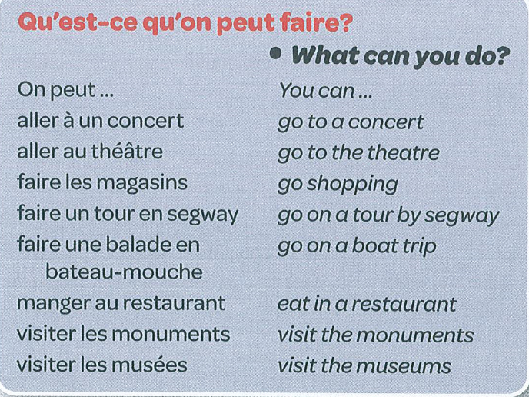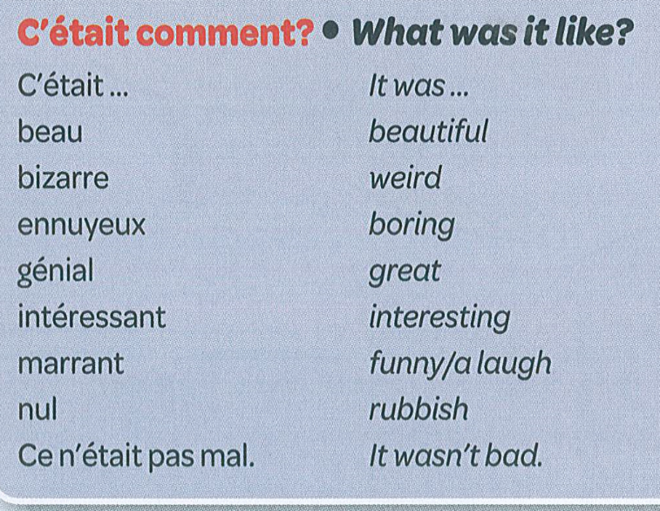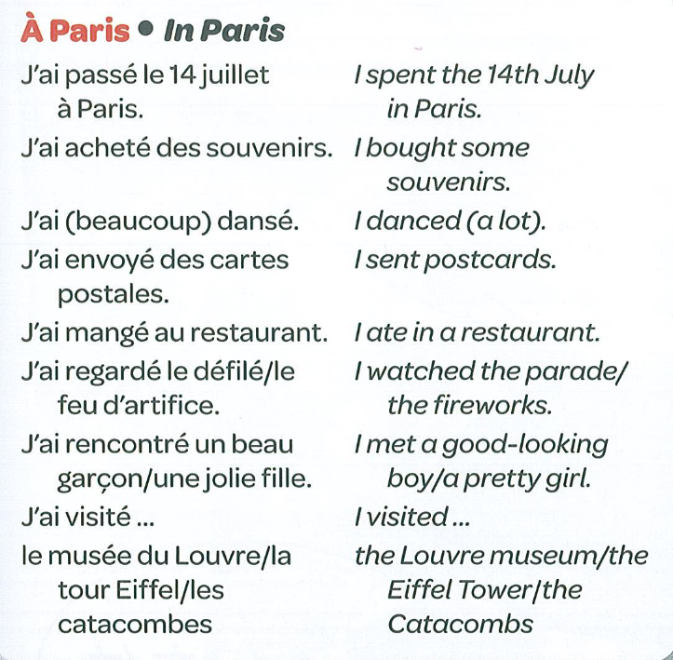

**À PARIS** (TALKING ABOUT WHAT YOU CAN DO IN PARIS)

