Key concepts, skills, questions or processes
What will I learn? | You will develop your understanding of the performing arts by examining practitioners’ work and the processes used to create performance.
What is a practitioner? | A practitioner is an individual or company who has a distinct style of performance, e.g. Brecht (Epic theatre), Stanislavski (Naturalism), Kneehigh, Frantic Assembly, Berkoff, Lecoq (Physical Theatre), 1927, Artaud (Absurdist/ Theatre of Cruelty), Boal (Theatre of the Oppressed), Paper Birds (Verbatim)
How will I do this? | You will watch a range of performances by professional rep in a range of styles. You will investigate how they created the pieces, and what influenced them, stylistically and contextually. You will also engage in workshops (lessons) where you will try out these styles for yourselves, and explore how different roles within the companies are linked together – e.g. director and actor/ puppeteer, set designer and choreographer, etc. You will keep a record of everything you are learning along the way.
What is expected of me? | It is vital that you keep an ongoing record, using your rehearsal logs, of everything we do in lessons, writing analytically (WWW/EBI) rather than just recounting the events of the lesson. You need to become critics as well as participants, showing an understanding of the processes behind the performance. You will have a number of assignments to submit, both practical and online/ written. You MUST keep on top of these assignments, as they all count towards your final grade.
What is an Assignment Brief? | This document explains exactly what you are expected to do, and how you will evidence it. The brief will also contain all your deadlines for submitting work. It details all the success criteria, so you should look at it often to ensure you are on track.
Key Vocabulary | Definitions & Explanations | Examples
Creative Intentions | What was the director/ writer/ creator thinking about? Themes / issues / response to stimulus / style/genre / contextual influences / collaboration with other practitioners / influences by other practitioners. | Look at your creative intentions sheet – have you been able to complete all the boxes?
Purpose | Why was it made? to educate / to inform / to entertain to provoke/ to challenge viewpoints / to raise awareness / to celebrate… | This is not a complete list – what other purposes can you think of?
Practitioners’ roles, responsibilities and skills | Performance roles e.g. actor / dancer / singer/ puppeteer, etc & Non-performance roles e.g: choreographer /set designer / director / writer etc. Responsibilities: rehearsing /performing /contributing to the creation and development of performance material, e.g. devising, designing, choreographing, directing, writing / refining performance material / managing self and others. Skills: physical, vocal and music skills, managing and directing skills, communication skills used to liaise, direct and perform, creative skills, such as designing set, costume, lighting or sound, writing scripts and composing songs, organisational skills used to put on a performance by a director or choreographer. | You will be expected to research a number of roles within the Performing Arts business, and explore how they work with each other to create a piece, e.g. How does the musical director of Kneehigh work with the director/ writer/ actors when creating a piece like FUP? Music is integral to the piece – look at how their creative process unfolds – it’s all on the website.  How do roles differ, depending on the company and the performance piece itself?
Processes used in development, rehearsal and performance | Responding to stimulus to generate ideas for performance material / exploring and developing ideas to develop material / discussion with performers / setting tasks for performers / sharing ideas and intentions / teaching material to performers / developing performance material / organising and running rehearsals / refining and adjusting material to make improvements / providing notes and/or feedback on improvements. | What does a good rehearsal look like? Can you use your rehearsal time productively? How do you do this? Do you assign roles? Do you keep track of decisions made? Are you asking other people to feedback their opinions?
Techniques and approaches used in performance | Rehearsal / production / technical rehearsal / dress rehearsal / performance / post-performance evaluation/review. | You need to track your progress from first ideas right through to post-performance evaluation. How have you made progress?
Evidence | As your qualification is based on continual assessment, rather than a terminal exam, you will be able to present your information in a number of ways: extended writing, a blog , a PowerPoint® presentation, teacher observations, recordings of workshops, recordings of performances. | You can be creative in the way in which you present your information. You will be given a template, but as long as you include all the relevant points, you can use any kind of presentation you want – posters, video interviews, etc.
Making Links (previous/future learning) – Recap and pre-reading! |  | 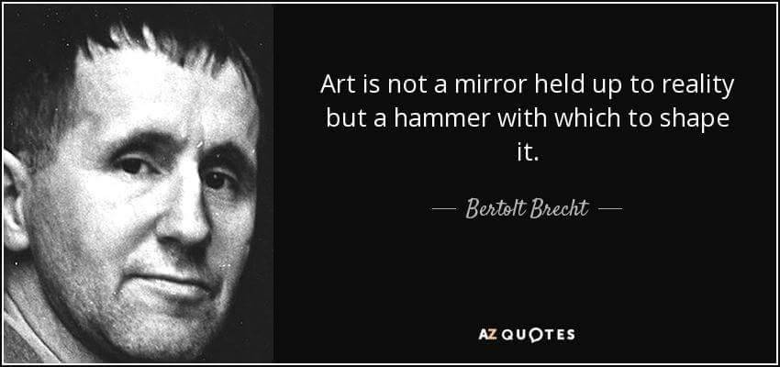
Recap: Skills learnt in Year 9 include physical theatre techniques (Frantic Assembly Techniques), live theatre review (The Goes Wrong Show), and practitioners. Look back at your work from last year – what can you take with you into this year?
Reading: There are lots of books on my bookshelf, and in the school library, which can help you, just ask what’s available!
Expand your knowledge and understanding! – useful websites/podcasts/videos etc…
One Stop-Shop – www.essentialdrama.com – featuring interviews and links to important practitioners, companies, styles, etc.
BBC Bitesize - https://www.bbc.com/bitesize/subjects/zbckjxs - covers everything from creating to evaluating, and lots of handy videos.
Techniques, Practitioners, Video Links - https://www.bgsperformingarts.com/drama.html
Kneehigh - http://www.kneehigh.co.uk/page/about_kneehigh.php
Frantic Assembly – https://www.youtube.com/user/franticassembly
National Theatre - https://www.youtube.com/user/ntdiscovertheatre

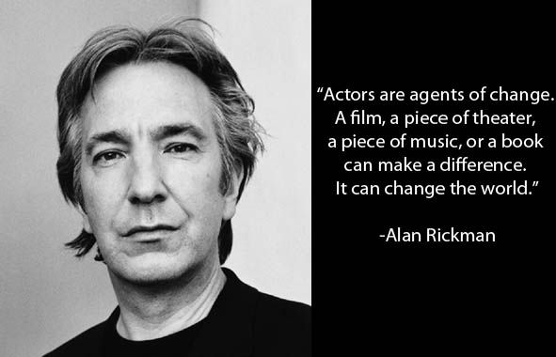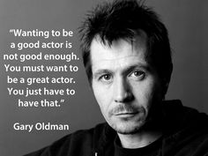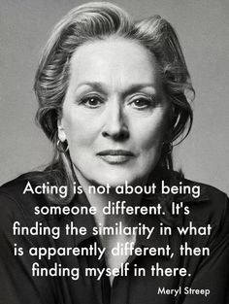
RESEARCH TASKS - TIPS
Use the guidelines given to shape your research – you will always be given specific areas to research, e.g. how a company rehearses, what their artistic intentions are, etc.
You should always be thinking, ‘how could I use this technique?’, ‘What effect would this particular style/ theme/performance have on the audience?’, ‘why did they decide to present the work in this way?’
Be curious! Look at videos of other companies on youtube and vimeo – educate yourself!
ACTOR’S LOG/ REHEARSAL LOG GUIDELINES
- What did you do? Explain the objective/purpose of each lesson/ series of lessons.
- What skills and techniques were we looking at?
- What did you find most challenging and why?
- What did you enjoy most and why?
- What are you doing well?
- What do you need to improve on?

Always use subject-specific language when writing your logs!
Logs should analyse and evaluate, not just recount!

