BTEC Tech Award Level 1/ 2 in Performing Arts
‘Naturalism’
Component 2 Autumn 2020
WHAT ARE you AIMING TO LEARN?
A How to develop skills and techniques for performance
TASK: Perform an extract from the play, in a naturalistic style.
- Focus on specific skills and techniques required, regarding voice and physicality/ movement. Your interpretative skills refer to how you interpret your character – how you play them – what you have inferred and imagined - this will depend on the amount of character development that you do.
- You MUST show evidence that you are using Stanislavski’s method to engage with your character.
- Develop your knowledge of Stanislavski, and use the elements of his method, through participation in workshops/classes.
- Apply rehearsal skills during workshops/classes, refining units and exercising teamwork skills.
WHAT EVIDENCE DO I NEED?
- Teacher observations
- Recordings of workshops/rehearsals/ discussions
- peer observations – (IN RED BOOKLET/ LOG BOOKS)
You need to be able to explain how these elements of Stanislavski’s system help the actor to ‘become’ the character.
In your logs, you should include some research about each strand, and explain how you have tried to apply it to your own performance.
Evaluate whether some aspects of the system are easier to use than others, and explain why this may be the case.

B How to apply skills and techniques in rehearsal and performance
TASK: Learn and memorise your script, applying technical, stylistic and interpretative skills to the performance.
- Unitise the script, and focus on blocking each unit before moving onto the next.
- Make notes by annotating your script, adding post-its, ideas.
- Objective: Always keep your character’s motivation at the forefront of your mind – what do I want to achieve? How will I show this through voice, body, proxemics?
WHAT EVIDENCE DO I NEED?
- Teacher observations
- Recordings – rehearsal, workshop performance
- Annotated script
- A3 Stanislavski sheet – exploring the text, using Stan’s methods.
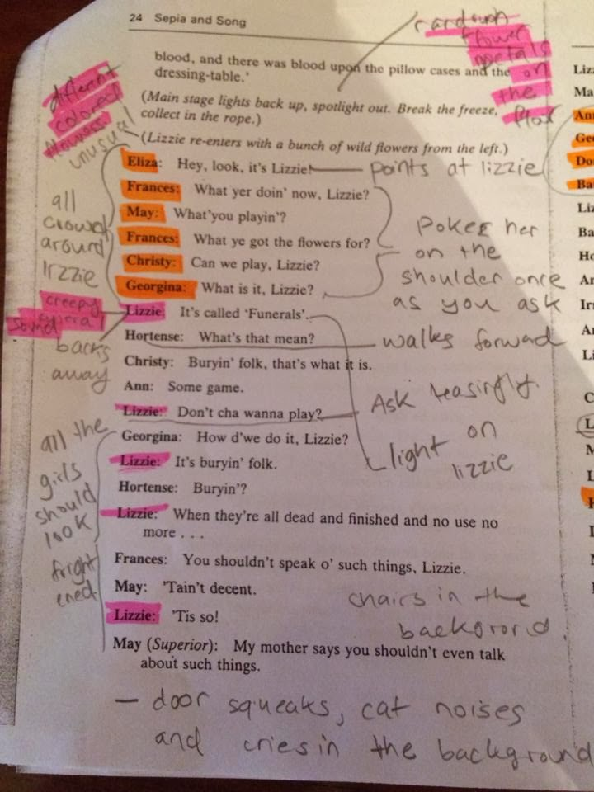
Add stage directions, instructions for your character, notes on blocking, pauses, and any other relevant information.
Every time you change/ make a decision about your character’s behaviour/ voice, write it down!
Use highlighters, different colour pens, post-its. Make your input …
STAND OUT!

C: How to review my own development and performance.
TASK: Make regular entries in your logbook, reviewing the progress you have made, focusing on strengths, areas for improvement and targets relating to technical, stylistic and interpretative skills.
- Write in specific detail – avoid ‘we knew our lines’ or ‘we listened to each other’ – this could refer to anything!
- What went well, and even better if statements.
- Use subject-specific language.
WHAT EVIDENCE DO I NEED?
- a logbook, to include: rehearsal/
development/
performance notes; strengths and improvements; target setting; response to peer feedback.
- video recordings – discussions/ feedback/ ideas for development

WHAT IS EXPECTED OF ME during this project?
You will be expected to:
- learn dialogue
- learn blocking and stage directions
- experiment with skills and techniques.
- interpret and develop a character
- communicate the genre of naturalism
- respond to direction, such as: applying health and safety procedures; being prepared; warming up and cooling down
- have a positive response to teacher instruction and feedback
- give feedback to your peers
- take in and apply feedback and corrections
- review and record the development of skills, techniques and progress in your logbook.
- display a positive behaviour and attitude when working with others - cooperation, being supportive, listening to others, punctuality, consistency, commitment, reliability, being prepared, being respectful of others’ opinions and skills.
