Classification of vegetables | Examples
Fruit vegetables | Aubergine, plantain, tomato, cucumber
Seeds and pods | Peas, beans, lentils
Flower vegetables | Broccoli, cauliflower
Leafy vegetables | Spinach, cabbage, parsley, lettuce
Stem vegetables | Asparagus, fennel, celery
Fungi | Different types of mushrooms
Tubers | Potato, sweet potato, yam
Bulbs | Onion, garlic, shallot, leek
Roots | Beetroot, swede, carrot, radish
Classification of fruit | Examples
Soft fruits | Raspberry, blackberry, redcurrant, strawberry
Citrus fruits | Orange, lime, lemon, satsuma
Stone fruits | Plum, apricot, peach, cherry, mango
Tree fruits | Apple, pear
Exotic fruits | Banana, kiwi, melon, pineapple
Dried fruits | Currant, date, sultana, raisin, fig
Starchy Carbohydrate | Examples
Bread | Bagels, baguettes, ciabatta, naan
Rice | Long grain  Short grain
Pasta | Spaghetti, lasagne, tagliatelle, penne
Cereals | Oats, wheat, rye
Safety
- Sharp knives: never walk around with a knife. Use the bridge hold and claw grip to cut safely.
- Grater: hold grater firmly on a chopping board. Grate food in one direction and leave a small amount at the end to prevent injury to knuckles.
- Hot liquid: drain hot liquid carefully over the sink using a colander.
- Saucepans: turn panhandles in from the edge, so they are not knocked.
- Hot equipment: always use oven gloves when placing food in and out of the oven.
- Spills: wipe up immediately.
- Electrical equipment: always follow instructions.

Preparing for practical work HABIT

H - Wash your hands and tie back hair
A – Put on an apron
B – Put your bags underneath the tables
I – Wait for your teacher to give you instructions
T – Do not talk and do not lean on the table
Knife Skills and Safety
Bridge hold Claw grip
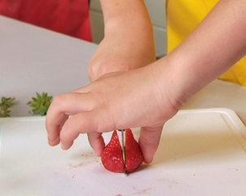
Protein | Examples
Meat | Chicken, beef, lamb, mince, ham
Fish | Tuna, cod, haddock,crab
Beans | Kidney beans, chickpeas, haricot beans
Nuts | Peanuts, walnuts, almonds
