Irregular verbs in the Present Tense: The verbs below do not follow the regular verb endings and must be learnt separately.

**Faire ( to do/ make)**

Je fais I do// make

Tu fais you do// make (sin/ inf)

Il/ Elle/ on fait he/ she/ we /does (do)// makes (make)

Nous Faisons we do// make

Vous faîtes you do// make (pl/ for)

Ils/ Elles font they do// make

**Lire (to read))**

Je lis I read

Tu lis you read (sin/ inf)

Il/ Elle/ On lit He/ she/ we read(s)

Nous lisons we read

Vous lisez you read (pl/ for)

Ils/ Elles lisent -they read

**Prendre ( to take)**

Je prends I take

Tu prends you take (sin/ inf)

Il/ Elle prend he/ she/ we take(s)

Nous prenons - we take

Vous prenez you take (pl/ for)

Ils/ Elles prennent they take

**GRAMMAIRE**

**The Perfect Tense**

**Step 1: Present Tense of Avoir**

J’ai – I have

Tu as – you have

Il/ Elle/ On a- he/she/ we have

Nous avons – we have

Vous avez – you have

Ils/ Elles ont – they have

**The Perfect Tense**

**Step 2: & Past participle**

Manger – mangé

Visiter – visité

Regarder – regardé

Écouter – écouté

Chanter – chanté

Jouer - joué

**The Perfect tense of -ER verbs**

You use the perfect tense to say what you did or what you have done.

To form the perfect tense of **–ER/ IR & RE** verbs you use:

Step 1: The present tense of **avoir** (to have)

Step 2; & **the past participle**

To form the past particle: of **–ER/ IR & RE** verbs

Take of the **–ER** and replace with **é**

Eg: Regard**er** = regard**é**

Take of the **–IR** and replace with **i**

Eg: Fin**ir** = fin**i**

Take off the **–RE** and replace with **u**

Eg: Attend**re** = attend**u**

Je jou**e** – I play

Tu jou**es** – you playIl / elle jou**e** – he / she plays

On jou**e** – we play

Nous jou**ons** – we play

Vous jou**ez** – you (plural) play

Ils / elles jou**ent** – they play

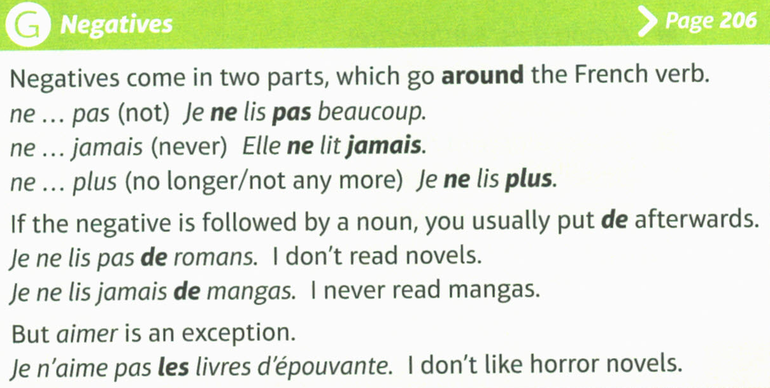

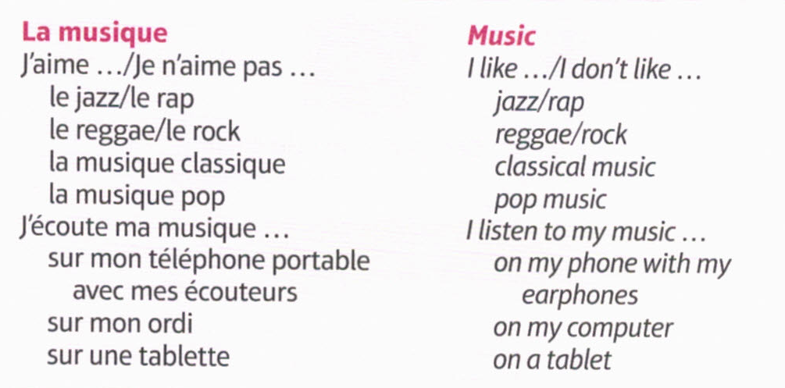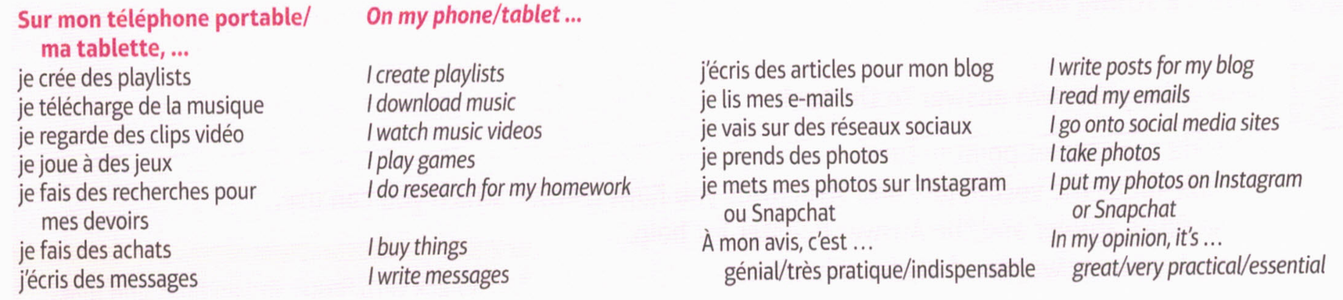

Yr9 - **LES TEMPS DE LOISIRS ( FREE TIME)**

