**GRAMÁTICA**

**Irregular verbs ‘ir’ – to go Stem changing verbs ‘jugar’ – to play**

(yo) voy – I go j**ue**go – I play

(Tu) V**as** – you go j**ue**gas – you play

Él/ella/usted) V**a** – he/ she/ you polite go j**ue**ga – he/she plays

(Nosotros) V**amos** – we go jugamos – we play

(Vosotros) V**áis** – you (plural) go jugáis – you (plural) play

(ellos / ellas) V**an**  - They go j**ue**gan – they play

(There are more stem changing verbs: Pref**ie**ro – I prefer /pr**ue**bo – I try)

**The Present Tense nadar – to swim (-er / -ir)**

(yo) Nad**o** – I swim **(-o)**

(Tu) Nad**as** – you swim **(-es)**

Él/ella/usted) Nad**a** – he/ she/ you polite swim **(-e)**

(Nosotros) Nad**amos** – we swim **(-emos / -imos)**

(Vosotros) Nad**áis** – you (plural) swim **(-éis / -ís)**

(ellos / ellas) Nad**an**  - They swim **(-en)**

(Some verbs are irregular in the ‘I’ form only:

Ha**go** – I do / sal**go** – I go out / ten**go** – I have )

**The Preterite Tense**

(yo) visit**é** – I visited

(Tu) visit**aste** – you visited

Él/ella/usted) visit**ó** – he / she / you polite visited

(Nosotros) visit**amos** – we visited

(Vosotros) visit**asteis** – you (plural) visited

(ellos / ellas) visit**aron**  - They visited

(Some verbs have spelling change in the ‘I’ form only:

jug**ué** – I played / lleg**ué** – I arrived / sa**qué** – I took )

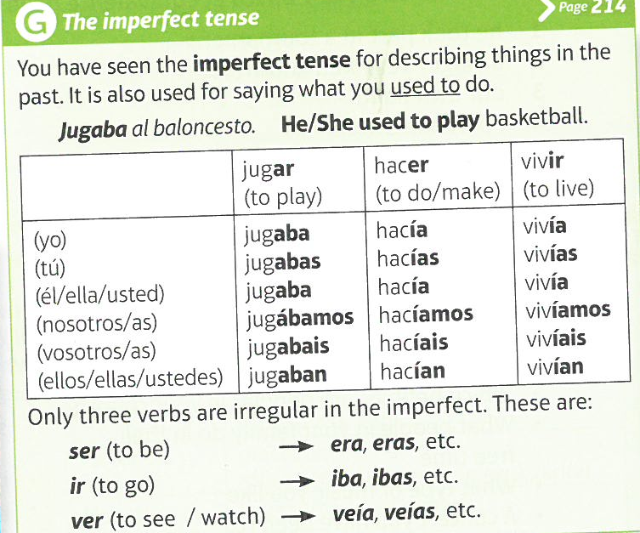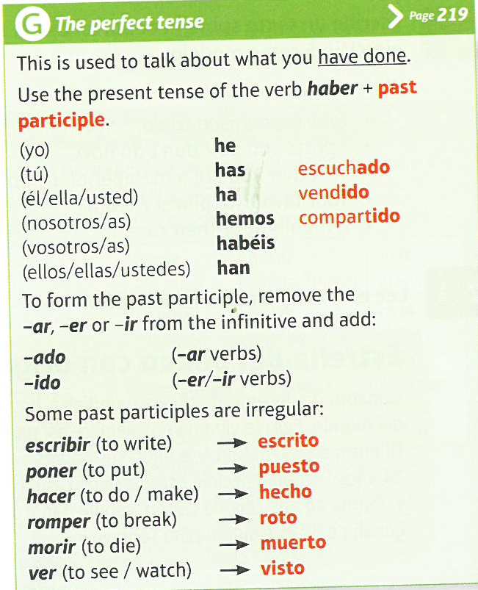

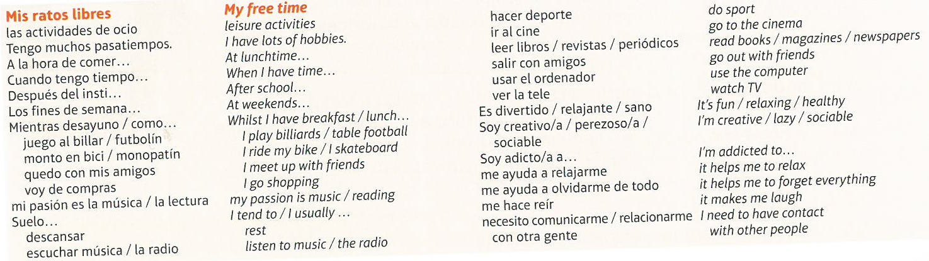

Yr 9- **INTERESES E INFLUENCIAS** (DESCRIBING PASTIMES) 

