LIC
Low Income Country
HIC
High Income Country
Newly Emerging Economy
NEE
Key Questions
What is development and how is it measured?
We measure development with social and economic indicators
such as GDP, life expectancy, infant mortality rate, and HDI.
HDI is arguably the most reliable because it takes into account both social and economic data. They tell us if a country is an HIC, NEE or LIC
What are the causes of uneven development?
Uneven development, or the development gap, is the difference in levels of development and wealth across the world. There are physical, economic and historical causes of uneven development. Physical include climate and natural resources, economic include trade links and a significant historical factor is colonialism
How did exploitation lead to the UK’s development?
Without colonialism and the slave trade, the UK’s industrial revolution would have been much slower. The UK's economy is founded in the slave trade and colonialism.
Is global consumption of resources unequal?
The UK's consumption of fossil fuels and resources, its industry, has not decreased. Its industry has just moved to other developing countries. The UK, like many HICs, still consume the most globally, proportionately to their population.
How is the UK connected to Africa?
British history is inherently African history, the history of the slave trade and colonialism across Africa shows that the UK has and still does rely on African resources
How is East Africa important?
The East African Rift Valley is a geographically significant area of the continent, with both human and physical features. Its natural resources and tourism industry are causing development
How is Tanzania developing?
Tanzania's natural resources and tourism industry, as well as its current rural-urban migration, are causing it to be one of the fastest developing countries in Africa
How is the UK connected to India?
India was extremely important to Britain in the world wars, and was exploited in a number of ways through trade, agriculture, labour and natural resources
How is India important?
India is abundant in significant physical and human features, and as an NEE is rapidly developing its technology, business and media industries. It is fast becoming a country of the global future, leading in many fields such as sustainable energy and tourism
How is India developing?
Rapidly growing industries in renewable energy, technology, business, tourism and media have enabled India to develop
Which emerging economies do you think are the future of the world?
All of the emerging economies we have studied have grown from the struggles of colonialism and the slave trade, and are fast becoming the future of the world. Which country do you think is going to develop into the most successful?

Geography Year 8 – Unit 1
Exploitation and Emerging Economies - Knowledge Organiser

1. development | When a country experiences positive change from increased money | 15. development gap | The difference in levels of development between countries
2. development measure | The way we measure how developed a country or region is | 16. primary/ secondary industry | Collecting natural resources e.g. mining/ manufacturing
3. social | To do with people’s lives | 17. tertiary/ quaternary industry | Services e.g. teaching/ science and technology
4. economic | To do with money
5. environmental | To do with the natural surroundings | 18. British Empire | The regions and countries under colonial rule of Britain
6. political | To do with government and activism | 19. consumption | Using resources
7. literacy rate | How many adults can read and write | 20. media | Mass communication e.g. tv, publishing
8. GDP per head  (Gross Domestic Product) | The total economic value of all the finished goods and services produced within a country's borders | 21. agriculture | Farming
 |  | 22. resources | A supply of something
9. infant mortality rate | Number of infants dying before their first birthday | 23. renewable energy | Energy created from an unlimited source
10. life expectancy | The average age a person is expected to live to | 24. solar power | Renewable energy created from the sun
11. exploitation | Taking advantage of something for selfish gain | 25. debt | Money owed to someone
12. colonialism | When one country takes political control of another, usually exploiting it | 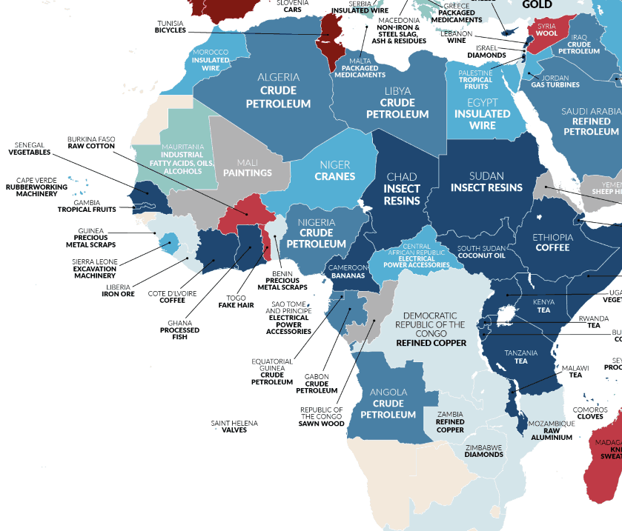  Imports from African countries to the UK
13. HDI  (Human Development Index) | How good the population’s quality of life is.
14. multiplier effect | When people spend money from their jobs in the local area, creating more jobs!

“Poor countries are not ‘under-developed’, they are over-exploited.”
- Michael Parenti

