**GRAMÁTICA**

**Stem changing verbs**

Stem changing verbs like **jugar** (to play) have regular ending, but some parts of the verb change the vowel in the “stem”. Often called “boot” verbs.

**Jugar – To play**

J**ue**go - I play Jugamos – we play

J**ueg**as – you play Jugáis – you play (plural)

J**ue**ga – he/ she plays J**ue**gan – they play

**The Infinitive**

The infinitive is the form of the verb used in a dictionaryor wordlist. In Spanish, verbs fall into 3 groups according to the endings of the infinitive:

* **AR; - ER: -IR**

Jug**ar** – to play Escrib**ir** - to write

Hac**er –** to do Viv**ir** – to live

Chate**ar** – to chat online Cant**ar** - to sing

Le**er** –to read Habl**ar** – to speak

**Irregular verbs: Hacer (to do)**

Hacer is an important irregular verb. The **c** changes to **g** in the “I” form.

**Hacer – To do**

Hago – I do

Haces – you do (singular)

Hace – he/ she does

Hacemos – we do

Hacéis – you do (plural)

Hacen – they do

**The Present Tense of regular –AR ending verbs**

**Hablar – To finish**

Habl**o** – I speak

Habl**as** –You speak

Habl**a** – He/ she speaks

Habl**amos** – We speak

Habl**áis** – You speak (plural)

Habl**an** – They speak

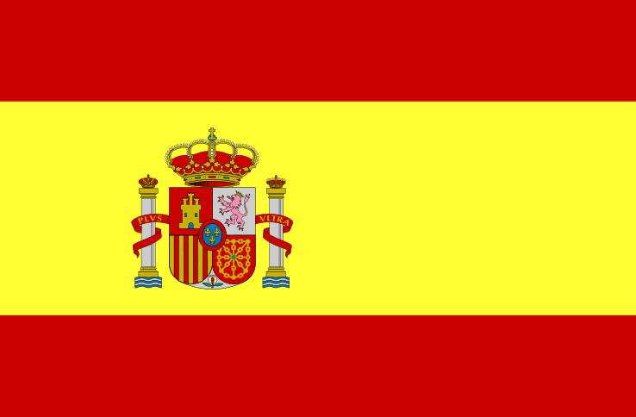

**Spanish Year 7: Viva 1 Module 2**

**MI TIEMPO LIBRE**  (MY FREE TIME)

