1066 | Norman Conquest
1315 | Great Famine
1326 | JPs first appointed
1340s | Black Death
1370s | Poll Tax introduced
1381 | Peasant’s Revolt over Poll Tax
1497 | Cornish Rebellion – against government taxes
How did they enforce law and order?
Feudal System – people pledged allegiance to the King
Church had strong control over society so rebellion and revolt was rare.

COMMUNITY ACTION helped enforce the law.

Tithings A group of 10 men who were all responsible collectively for each other’s behaviour
10 tithings were grouped into a Hundred and the Hundredman dealt with serious crimes.
The community had responsibility to shout and chase criminals in their area by raising the Hue and Cry.
The Sheriff had the authority to raise a posse to catch criminals.
After the Norman Conquest – JPs; royal courts; Parish Constables, watchmen introduced.
Saxon and Medieval Crime and Punishment
c.500 - 1485

Causes and Nature of Crime
Theft: 73.5% of all offences Murder: 18.2%
Receiving stolen goods: 6.2%
Arson, counterfeiting coins, rape, treason – 2%
POVERTY – famine and disease; government taxation; impact of warfare

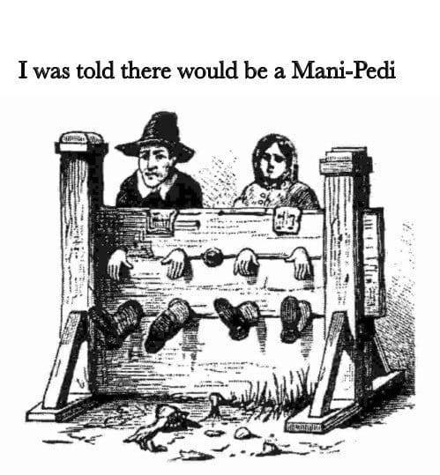

Attitudes to Crime

Deterrence | To scare people into not committing a crime
Retribution | ‘An eye for an eye’- the idea that the punishment should fit the crime
Public Humiliation | Also a deterrent and to scare others
Punishments
Corporal Punishment – Physical punishment
Theft = mutilation (cutting off a body part)
Heresy (going against the official religion) = burning at the stake
Murder = Hanging
Drunkenness = Stocks
Gossiping = Scolds’ Bridle

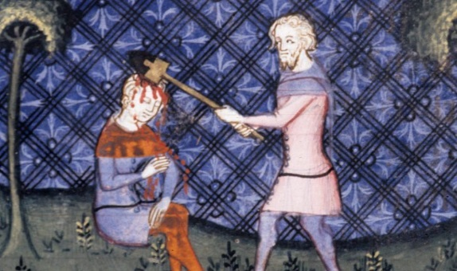
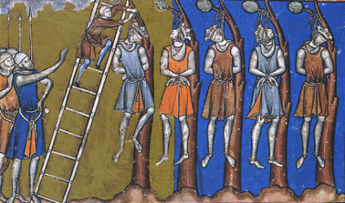

1536 | Dissolution of the Monasteries (Henry VIII shuts them down and there is no more help for the poor)
1536 | Pilgrimage of Grace: religious rebellion
1553-58 | Mary I executes 283 Protestants
1550s | Poor harvests lead to increase in poverty
1600 | Population of Britain is 4.5 million
1601 | JPs used to administer Poor Law
1605 | Gunpowder Plot (treason)
1663 | Charleys introduced
1717 | Transportation formerly starts
1750s | Bow Street Runners set up.
How did they enforce law and order?
1500s – 1600s, continuity with Medieval times. Change came in 1700s when population rise meant this was unsustainable.
Gradual in 1700s to preventative policing. Bow Street Runners (Henry Fielding)
Early Modern
c.1485 - 1750

Causes and Nature of Crime
Theft continued to be most common (75% of all crimes).
POVERTY increased because of poor harvests; increase in population; rack-renting; enclosure; Dissolution of the Monasteries
Increase in crime linked to the changes in RELIGION under the Tudors and Stuarts (heresy/treason)
GOVERNMENT TAXATION led to smuggling in 1700s.
Increase in Highway Robbery

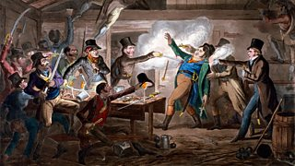

Punishments
1500 – 1700 NO REAL CHANGE.
1700s – GRADUAL CHANGE: Transportation (sending prisoners to USA then Australia).
Hulks – shops used to hold prisoners while they waited to be transported.

Attitudes to Crime
1500-1700 CONTINUITY with Medieval times. Deterrence, retribution; public humiliation
1700s – GRADUAL CHANGE towards the idea that the punishment should fit the crime; Bloody Code seen as too harsh.

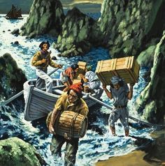
Find out more: BBC Bitesize has a good revision website for Crime and Punishment. Watch Tony Robinson’s CH4 documentary of the same name on Youtube.

1784 | Tax Reform Act –duty on tea reduced from 119% to 12%. Leads to decline in smuggling
1800 | Population of Britain is 16 million
1829 | Metropolitan Police Force set up
1823 | Prison Act – rules regarding security and health
1831 | Last recorded Highway Robbery
1839 | Prison Act – Separate System introduced
1856 | County and Borough Police Act makes it compulsory to have a police force
1865 | Penal Servitude Act – Hard Labour/Hard Fare/Hard Board
1868 | Public Execution ends
1900 | Population of Britain is 42 million
1901 | Fingerprinting
1902 | Borstal opens
1919 | First women in police
1920 | Dangerous Drugs Act
1930s | Police cars become common
1955 | Ruth Ellis is last woman hanged in Britain
1965 | Capital Punishment ends
1967 | Parole introduced
1983 | Compulsory to wear seat belt in car
1986 | DNA first used as evidence in murder trial
1970s | Bombing campaign by IRA
1996 | Manchester Arndale Centre bombed
2002 | Community Police Officers introduced
How did they enforce law and order?
1829 Metropolitan Police set up by Robert Peel– MAJOR TURNING POINT.
From then on – government responsibility
Specialised policing in 20th century: change in use of transport, technology, electronics and forensics.

Modern
1750 - present
Causes and Nature of Crime
Theft, robbery, assault still common. Changes in technology has dramatically changed nature of crime
Car crime – committed by people of all social classes. New crimes committed as laws changed.
Cyber-crime – hacking; phishing; cyber-bullying
Violent Crime – football hooliganism/ Gun and Knife Crime/Drug Crime
POVERTY still major cause of crime. Also social changes.

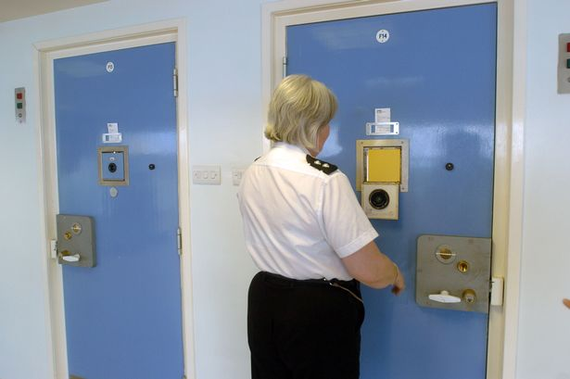
Attitudes to Crime
MAJOR CHANGES after 1900
Shift away from toughness to rehabilitation and reform (the idea that criminals could be changed with help) and alternatives to prison
Punishments
1800s –Reform of the ‘Bloody Code’ led by Sir Samuel Romilly and Robert Peel. Reduced the number of crimes punishable by hanging.
1800s – Increasing use of prisons. Prison reformers: Elizabeth Fry, John Howard, GO Paul. Introduction of the Separate and Silent Systems.
But 1865 – back to ‘hard labour, hard fare, hard board’
20th century: Huge change in reform of prisons. Categorised A-D depending on seriousness of offenders; ‘open prisons’, juvenile prisons, women’s prisons.
Alternatives to prison = parole, fines, community service, electronic tagging, drug and alcohol rehabilitation

