Appearance | Aroma | Taste | Texture
dull flat Crisp  lumpy fluffy fizzy  Stringy heavy crumbly  firm dry flaky  smooth crystalline HARD  Mushy sticky  fragile weak spicy | aromatic pungent perfumed  floral scented fragrant  mild citrus STRONG  musty acrid tart  rotten savoury rancid  tainted bland | Sweet cool bitter  umami zesty warm  HOT tangy sour  sharp Rich salty  bland rancid tart  acidic STRONG citrus  mild spicy tainted  weak savoury | brittle rubbery short  gritty  clammy close  stodgy bubbly sandy  tacky tender waxy  open soft firm  flaky crisp fluffy  dry crumbly  lumpy  smooth HARD Mushy  sticky
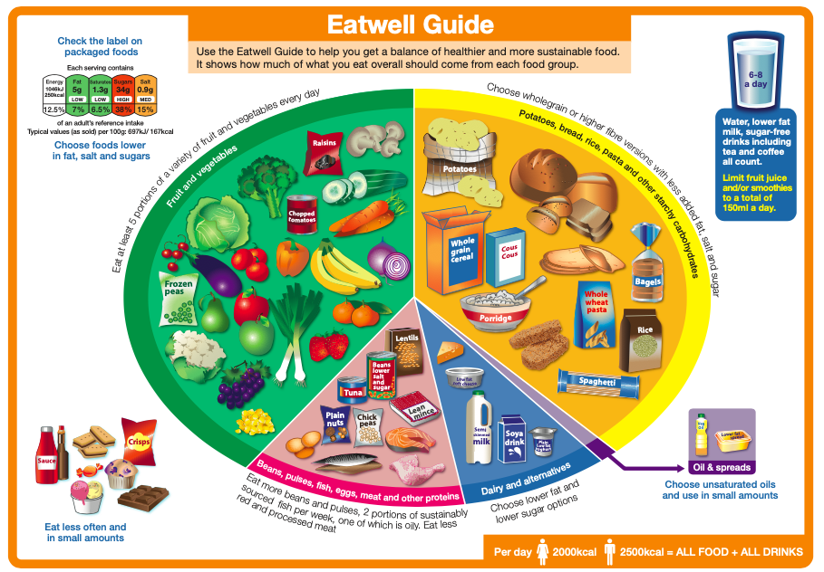
Keywords
Contamination – when a hazardous substance and been introduced into something else
Saturated Fats – usually from animal sources, can be harmful to health
Unsaturated fats – usually from plants sources, can be good for health
Simple Carbohydrates- from foods like sugar, treacle, syrups, jam. Gives energy in a short burst
Complex Carbohydrates – from foods high in starch, like potatoes, bread and pasta
Complete ( HBV) protein- Protein foods from meat, fish, eggs
Incomplete ( LBV) protein – Protein foods from plant sources, such as nuts, seeds, peas and beans

How can you use these words to describe the food you make in your practical lessons or at home?

Information on a Food Label
- The name of the food
- An ingredient list
- Information on certain foods causing allergies
- The net quantity of the food
- A date of minimum durability
- Any special storage conditions
- The name and address of the manufacturer
- The country of origin
- Instructions for use
- Information on nutrition

Year 8 Food, Cooking and Nutrition Knowledge Organiser

