July 2021

Dear Parent/Carer,

I am writing with some further updates to my end of year letter.

The Government has updated it’s guidance on face coverings. They are now asking children
to wear face coverings on public transport when they travel to and from school in September. Further to this I am also happy for children to continue to wear a face mask in school as a matter of personal choice. Face masks worn in school must be plain black or blue, or a surgical style mask.

If there are any further updates to the guidance during the summer holidays I will write you before the start of term.

Finally, in my last letter I omitted Miss Harnett from our staff leavers list. I am very grateful for Miss Harnett’s hard work over the last year.

Please pass on my thanks to all of the children for their hard work and effort this year.

Peace Be With You
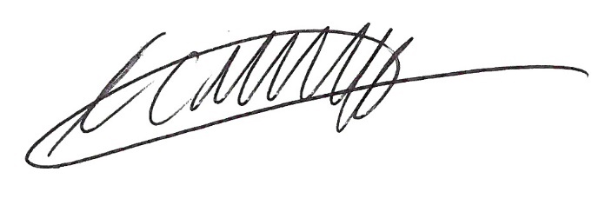
Kevin Maddocks
Headteacher

